iGROW COACHING FORM

Full Name: Jamaica Placer | Date: February 3, 2021
Employee No.: 01564 | Immediate Supervisor: Phoebe Rendeza

Issue / Goal - What is the issue and goal of the coaching session?

Jamaica failed to pass the monthly goal of 75 for the month of January. / To make sure that rep understands the importance of meeting and exceeding the monthly productivity goal.

Reality / Options – Root Cause Analysis and Agent’s Feedback
I was not able to reach the quota last month for my internet was not stable sometimes. Also, some of the orders sent to me has been worked already.

Way Forward – Action Plan and Setting Proper Expectations

I already upgraded my internet connection.

Set proper expectations that next time the agent commits the same offense this will be dealt with accordingly.

Employee Signature: 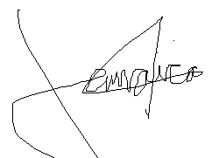 | Date: February 3, 2021
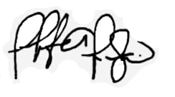  Supervisor Signature: | Date: February 3, 2021

