iGROW COACHING FORM

Full Name: Sarrah Marie Ferraren | Date: March 1, 2021
Employee No.: 1679 | Immediate Supervisor: Joan Mamac

Issue / Goal - What is the issue and goal of the coaching session?

- Mishandling of orders. WIP Date Needed were changed with no other action on the order.
- Not doing follow ups correctly. Been calling Dr. and PT for more than three attempts.

Reality / Options – Root Cause Analysis and Agent’s Feedback
Spoke with the rep and she said her reason for changing the follow up date with no productive action was for those orders not to be tagged as backlogs, these orders were not counted on her numbers those days as well she is just avoiding these orders to pile up under backlogs.

Discussed to the rep the possible effect of changing the FU date from time to time this will prolong the order and will make it hard for us to obtain approval the fastest way.

Rep said she will make sure this won’t happen moving forward on her orders.

Way Forward – Action Plan and Setting Proper Expectations

Discussed to the rep that this will fall under mishandling of orders in where they signed a memo way back that can lead to suspension and their dismissal if it will progress.

Discussed to the rep that right process when doing the follow ups also we need to stick to the three attempts and all possible action should be done on the same attempt.

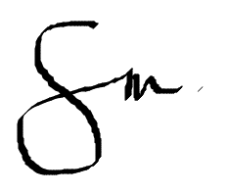
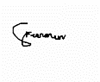  Employee Signature: | Date: March 2, 2021
Supervisor Signature: | Date: March 1, 2021

3249599 – no other action aside from changing WIP Date Needed from time to time
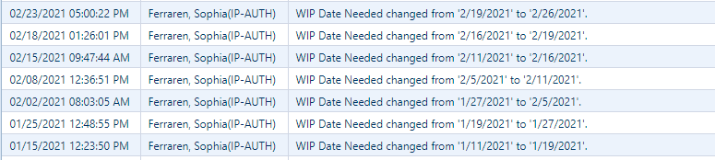
3256428 – no productive action
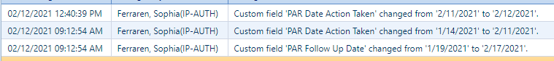
3467793 - no other action aside from changing the WIP Date Needed

Sophia – Wrong Follow Up process
3364486 – been calling the Dr. and PT for a couple of times now order opened for 128 days should have been escalated.
