iGROW COACHING FORM

Full Name: Marie Grapes Navoa | Date: May 20, 2021
Employee No.: 1973 | Immediate Supervisor: Metchie Claire Calo

Issue / Goal - What is the issue and goal of the coaching session?

Athena failed to reach the QA score for the month of April 2021.

AGENT | QA SCORE GOAL | QA SCORE | REMARKS
Marie Grapes Navoa | 90% | 85% | Failed

Reality / Options – Root Cause Analysis and Agent’s Feedback
For the month of April I’m having a hard time understanding the updates that is why I was not able to reach the goal score for the quality.

Way Forward – Action Plan and Setting Proper Expectations

I will make sure to correct my mistakes and try my very best to understand the process. And I will ask my teammates for help so that I will be able to understand more and learn from them. Thank you and God bless.

Employee Signature: 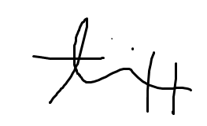 | Date: May 20, 2021
Supervisor Signature: 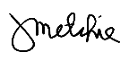 | Date: May 20, 2021

