iGROW COACHING FORM

Full Name: Shirry Mae Ycot | Date: May 20, 2021
Employee No.: 1997 | Immediate Supervisor: Metchie Claire Calo

Issue / Goal - What is the issue and goal of the coaching session?

Athena failed to reach the QA score for the month of April 2021.

AGENT | QA SCORE GOAL | QA SCORE | REMARKS
Shirry Mae Ycot | 90% | 88% | Failed

Reality / Options – Root Cause Analysis and Agent’s Feedback
I wasn’t able to meet the passing score due to the reason that I was overwhelmed of the everyday updates and changes on how to QA each SO’s with different payor. Because of focusing on the new updates and coping up, some parts of the process was missed to check and the reason of my failure.

Way Forward – Action Plan and Setting Proper Expectations

- Upon doing QA, each SO’s will be checked carefully and accordingly.
- Immediately approach and ask questions whenever there are confusions about the orders.

Set proper expectations that next time the agent commits the same offense this will be dealt accordingly.

Employee Signature: 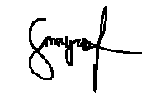 | Date: May 20, 2021
Supervisor Signature: 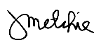 | Date: May 20, 2021

