CERTIFICATION OF EMPLOYMENT

To whom this may concern:
This is to certify that EMMANUEL MICHAEL V. OSIA as OUTBOUND SALES EXECUTIVE from August 17, 2021 up to October 7, 2021. FORWARD THINKING SERVICES PHILIPPINES, INC (FTSP INC), a Business Process Outsourcing (BPO) company with office address at 15th floor, HM Tower, corner West Geonzon St., Cebu IT Park., Apas, Cebu City.
This certification is issued to EMMANUEL MICHAEL V. OSIA upon his request for whatever legal purpose it may serve.
Issued this 15TH day of December 2021 at Cebu City, Philippines.

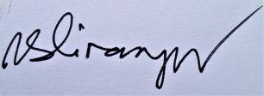

Vitus S. Dinampo
HRD Manager

