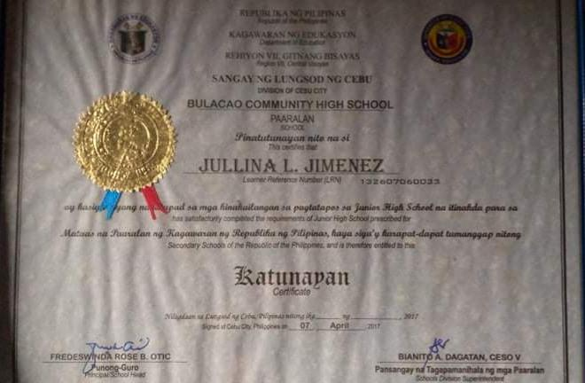
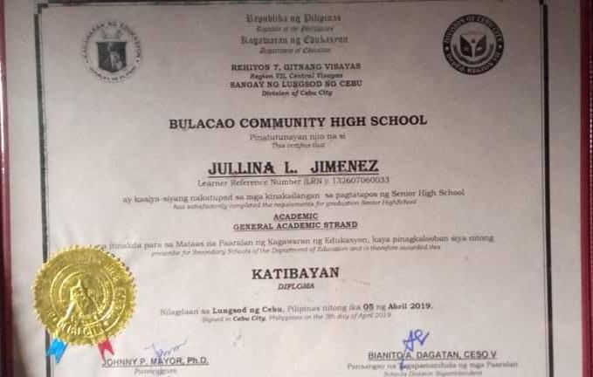
JULLINA JIMENEZ
DIPLOMA (JUNIOR-SENIOR HIGH SCHOOL)

