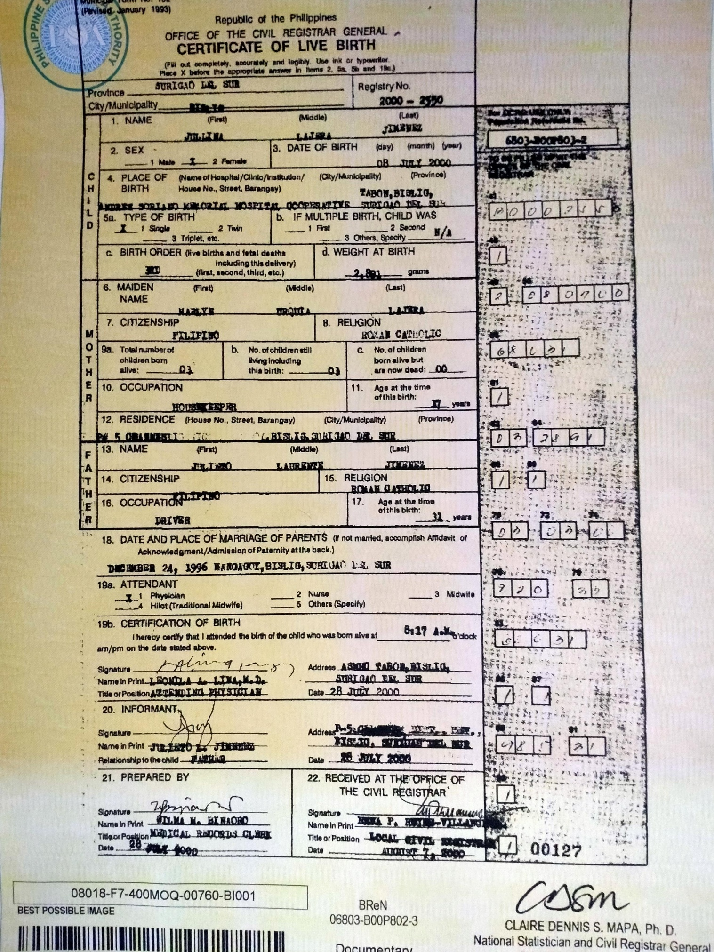
JULLINA JIMENEZ
PSA (BIRTH CERTIFICATE)

