
iPloy Incorporated
9th Floor Ayala Center Cebu Tower, Cebu Business Park, Cebu City
March 7, 2022
Wilfredo Noquiao Benaro Jr. Maracas Lahug Cebu City. 6000
Dear Mr. Benaro Jr.
Congratulations!
iPloy Inc. is pleased to offer you the position as CSR - Phone (voice) We expect you will impart your knowledge, skills, and experience to your work.
Should you accept this job offer, per company policy you will be eligible to receive the following beginning on your hire date.
- Possible* Gross Monthly All-in Compensation: PHP21,000.00 ● Breakdown of Monthly Compensation: ○ Basic: PHP 16,000.00
○ Allowance: PHP 2,400.00
○ Night Differential: 10% from 10 PM to 6 AM (MNL) – Php 1,600.00
○ Attendance Bonus (No Absent, No Late) – PHP 1,000.00
- 25K Sign-On Bonus (Terms and conditions will be discussed on site) ● Government mandated benefits; SSS, PHIC, and HDMF.
- Expected workdays from Mondays-Fridays**. A total of forty (40) hours a week.
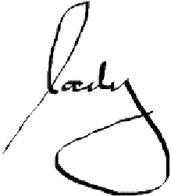
* Possible gross monthly compensation is based on complete attendance, no tardy and shift covered within fnight differential, this is before tax, and government mandated benefits deduction. ** Unless specified by the clients.
Yours truly,
Lady Fair Pazon
HR Recruitment Supervisor
Conforme:
You will be hired on Probationary status for a six (6) months period. Performance review will be conducted on the 3rd and 5th month of your employment with the company to check your suitability to the position. If your performance meets our standards, then you will be converted to regular status. Furthermore, you will get a proportionate of (10 VL & 10 SL) within the year, NSD and HMO.
If you are amenable to this job offer, your tentative hiring date will be on TBA at 10:00 PM.
iPloy Inc. through the Human Resources Department will provide you with a written employment contract and personally discuss with you full details of your employment.
Should you have any concerns regarding the details of this offer, please feel free to ask.
By signing and dating this letter below, I Wilfredo Noquiao Benaro Jr. accept this job offer as CSR - Phone (voice), for iPloy Inc.

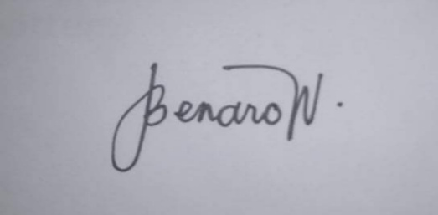
Wilfredo Noquiao Benaro Jr.
Signature over printed name Date: 03/07/2022

