

Tech Mahindra Limited
7th Floor Ebloc 3 Cebu IT Park, 14th Floor FCC Bldg., Cebu IT Park, Cebu City 6000, Philippines
CBU: Tel +63 32 410 6499

CERTIFICATE OF EMPLOYMENT

This is to certify that Lories Ann Quindala has been an employee of VCUSTOMER CEBU, INC. (a Tech Mahindra Ltd. Company) from November 23, 2018 to April 19, 2022. He/she held the position of Associate- Customer Support.

This certification is being issued upon the request of Lories Ann Quindala for reference of employment with the Company. VCUSTOMER CEBU, INC shall not be held liable if this certification is used other than the purpose indicated. For inquiries, you may email us to CebuER@TechMahindra.com.

Issued on April 21, 2022

Issued by:

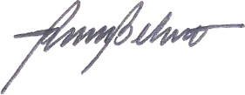
REYNALDO BELUSO II, JD.
Manager, Human Resources

