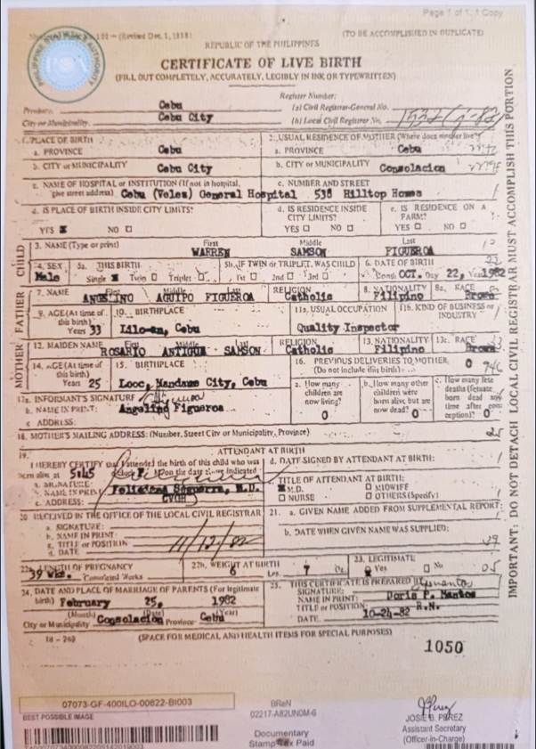
Cabe
7. NAME
MOTHER, FA
101 - 1,11511
TO BE ACCOMPLISHED IN DUPLICATE REPUBLIC OF THE PHILIPPINES CERTIFICATE OF LIVE BIRTH FILL OUT COMPLETELY, ACCULATELY, LEGISLY IN INKOR TYPOVRITTEX)
Regler Caba
Tal Collegrar General No.
hile Retirer PLACE OF BIRTH
: : ...USUAL RESIDENCE OF MUTITER We docs where
SUN PROVINCE
3. PROVINCE CITY SILNICIPALITY Cabo City
CITY MUNICIPALITY Consolida y NAME OF HOSPITAL INSTITUTION (Ir not in hospital,
c. NUMBER AND STREET De reddim) Cole (Veles) Goperal Hospital 536 Alltop Homs 4. IS PLACE OF BIRTH INSIDE CITY LIMITS:
4. IS RESIDENCE INSIDE IS RESIDENCE ON CITY LIMITS?
FARM YrS NO E
YES O NO DO YES O NO O 3. NAME (Type or print)
Middle WARREL SAMSON
FIGUEROA 4. SEX STILS BIRTIE
S . IF TWIN O TRIPLET WAS CHILD 6 DATE OF BIRTII Sungle 1 Tuvin D Tripleto
2nd . Cons. OCT. Dy 22, 1925 Agostino DUIPO PIGUEROA RESOL
TOS, SENSE 9. AGE(At time of. 10.. BIRTHPLACE
IS USUAL OCCUPATION 176. KIND OF BUSINESS
INDUSTRY Years 33 Talota, Coba
Quality Inspector
RELIGION 12. MAIDEN NANE Safitos
NATIONALITY - Salso
. RACE bou l ine tes
2 14. .CE (Atne of 15.' BIRTHPLACE .
16. PREVIOUS DELIVERIES TO MOTHER O F
(Do not include illis binh).. Year 25 Looc, Mandae City, Cabe
flow many
Ib. I low many other low many 17. INFORMANTS SIGNATURF ALL
desta children art cidere
big buto NALE INPUT:
del Angalind Figueros..
cow living .
www dead! ADDRESS:
option 18. SOTITURS SAILING ADDRESS: (Nuber, Suert Cleor Municipality, Province)
ATTENDANT AT BIRTH THEREUY CERTY tende the Wirth of this chad who wad. DATT SIGNED BY ATTENDANT AT BIRTI: x Solis
Bantur day DALMAUSE
L
idinis
A TITLE OF ATTENDANT AT BIRTI: NAME IS PRETO
, LA
ONLOWIFF ADDRESS:
ONURSE. O OTHERS (Specify 20 B IJVED IN THE OFFICE OF THE LOCAL CIVIL REGISTRAR 21. GIVEN NAMIE ADDED FROM SUPPLEMENTAL REPOK
SIGRATUVE: . NAMF IN PRINT
D. DATE WHEN GIVEN NAME WAS SUPPLIED: TITIS POSITKIN
9 12. LEGITIMATE 27h, WEIGHT AT BIRTH Comedo
Les 7
Yes ON 34 DATE AND PLACL OF MARRIAGE OF PARENTS (or legate
3. TITIS CURTETES KERKDOW Ter 25, 1982
KAHE IN PLINT Dora Ponto
TITLE OF POSITION Cyw ny Cosoladores Contacan
DATE (SPACE FOR MEDICAL AND HEALTH ITEMS FOR SPECIAL PURNSES)
1050
IMPORTANT: DO NOT DETACH LOCAL CIVIL REGISTRAR MUST ACCOMPLISH THIS PORTION
-
Ở
bà
)
|
D.
DATE
OF PRIGNANCY
SIGNATURE
20-22R.N.
07073-GF-4OOILO-00822-B1003 BEST POSSIBLE IMAGE
BRON 02217-ABUNOMG
Documentary Stamp te Paid
JOSE. PREZ Assistant Secretary (Officer in Chapel

