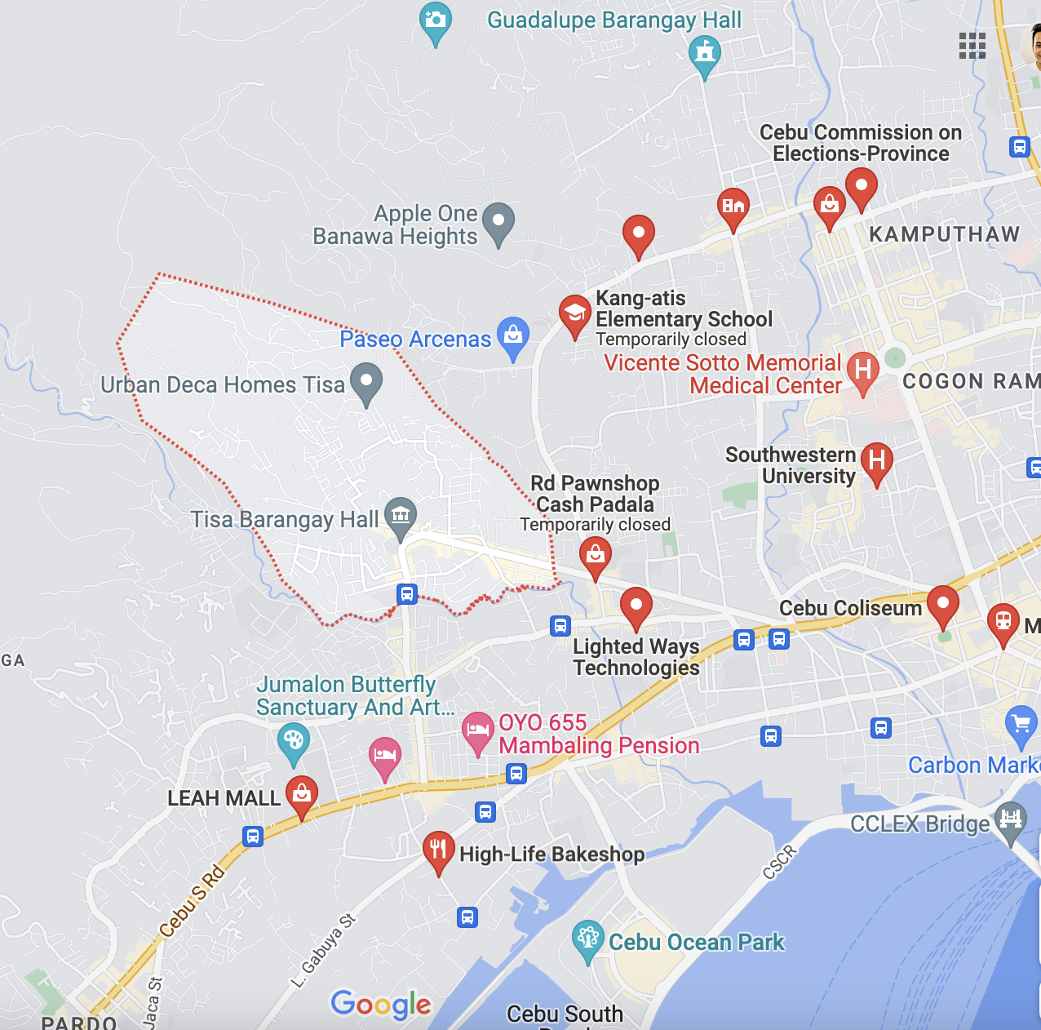
Legend:

Urban Deca Homes Tisa 2, Brgy. Tisa, Cebu City, Cebu

