1ST YEAR- 1ST SEM

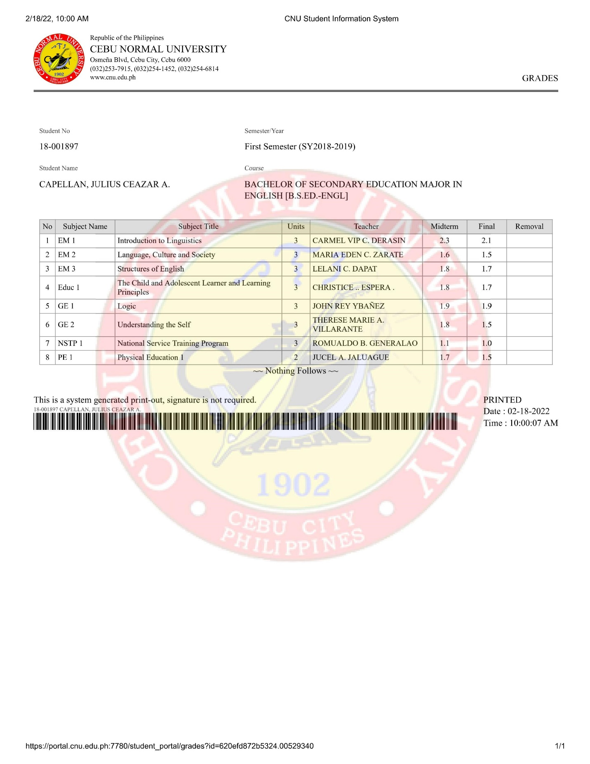

1ST YEAR- 2ND SEM

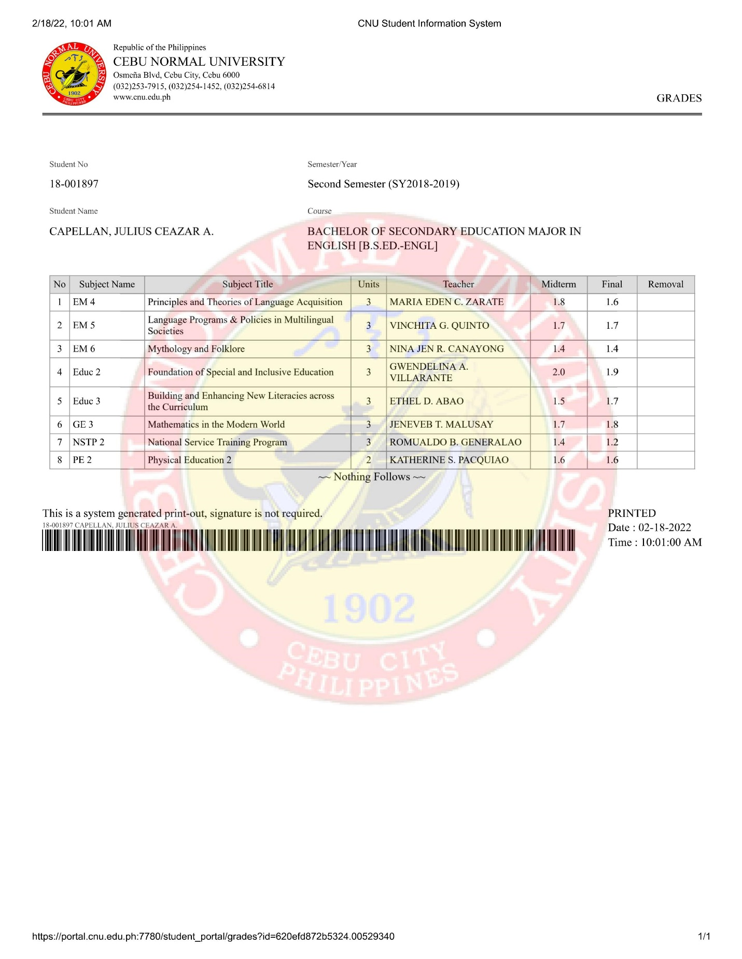

2ND YEAR- 1ST SEM

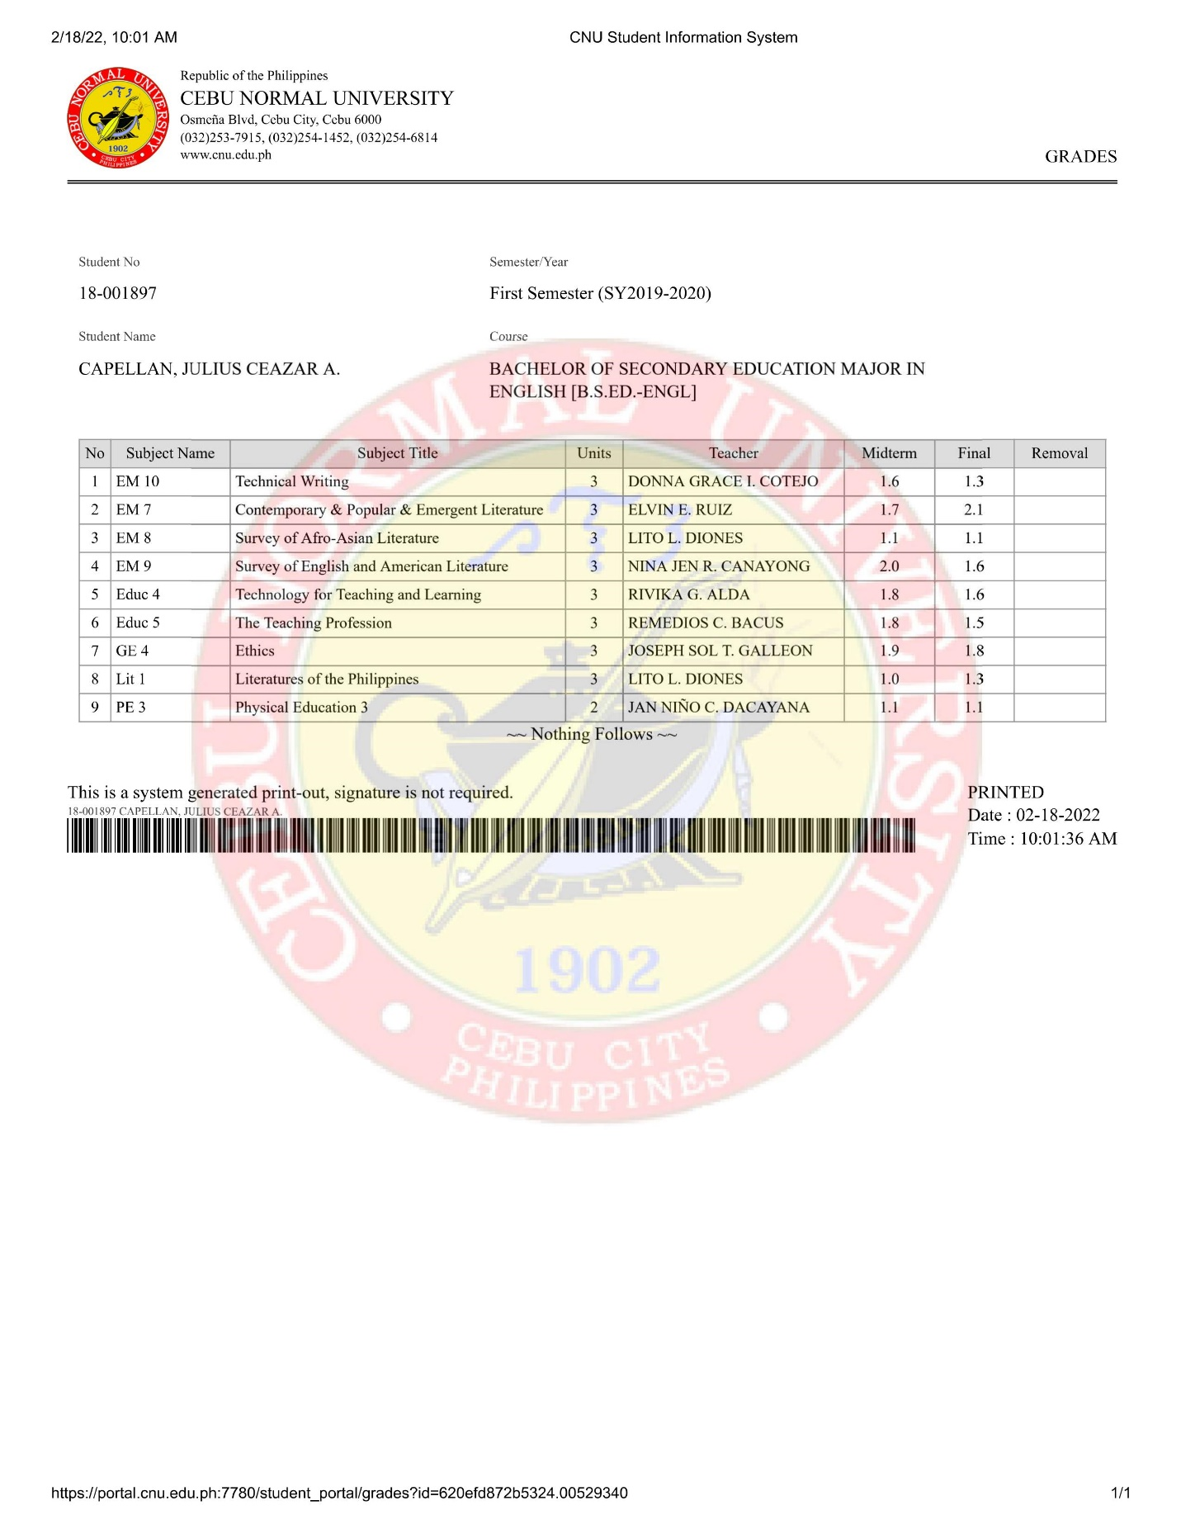

2ND YEAR- 2ND SEM
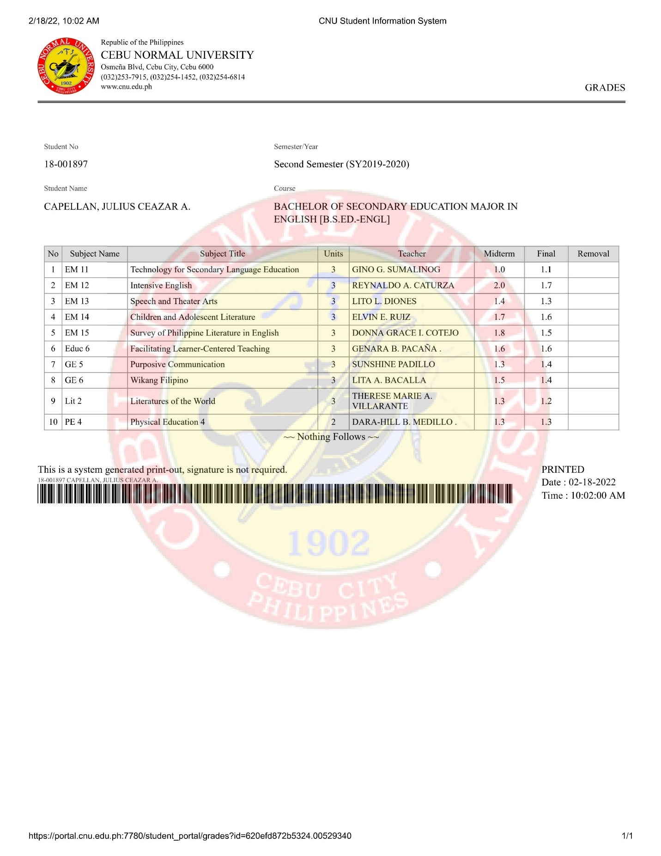

3RD YEAR- 1ST SEM
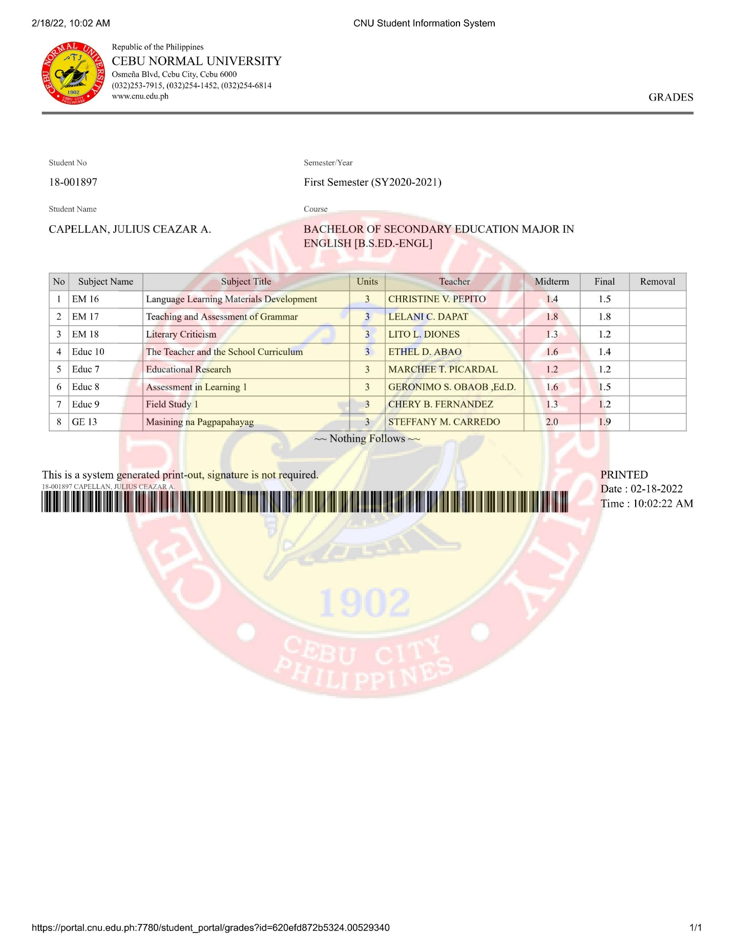

3RD YEAR- 2ND SEM

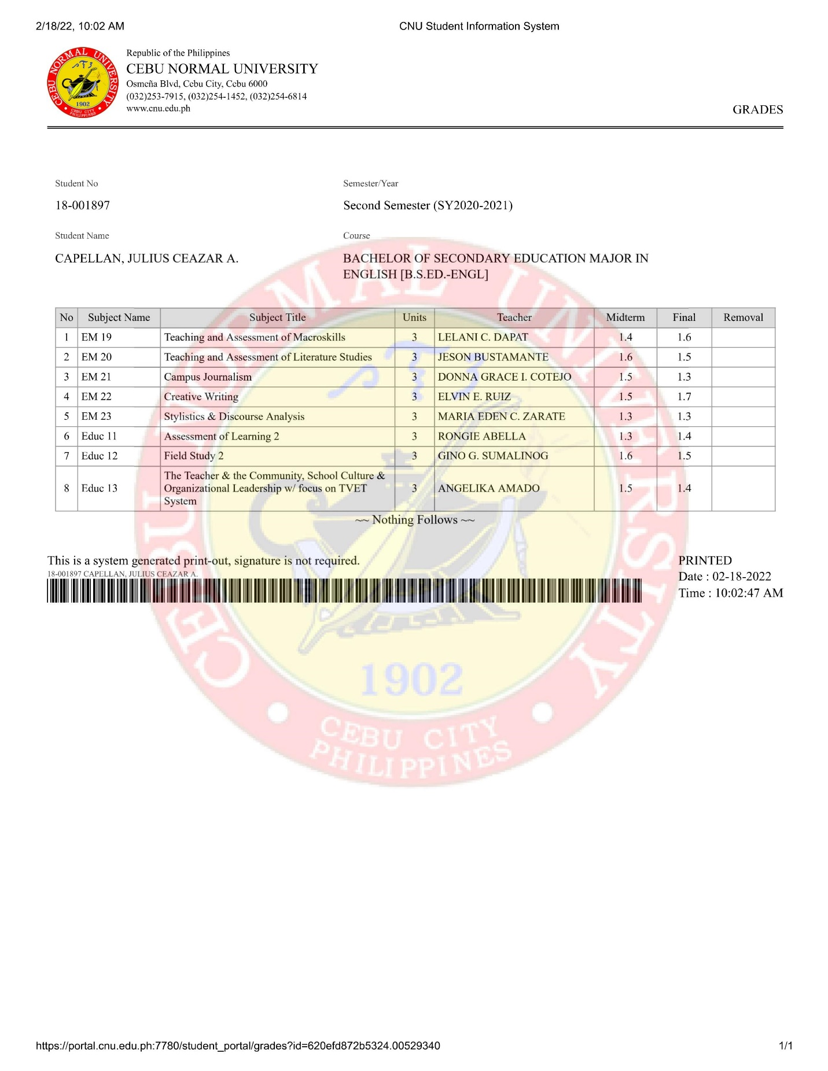

4TH YEAR- 1ST SEM

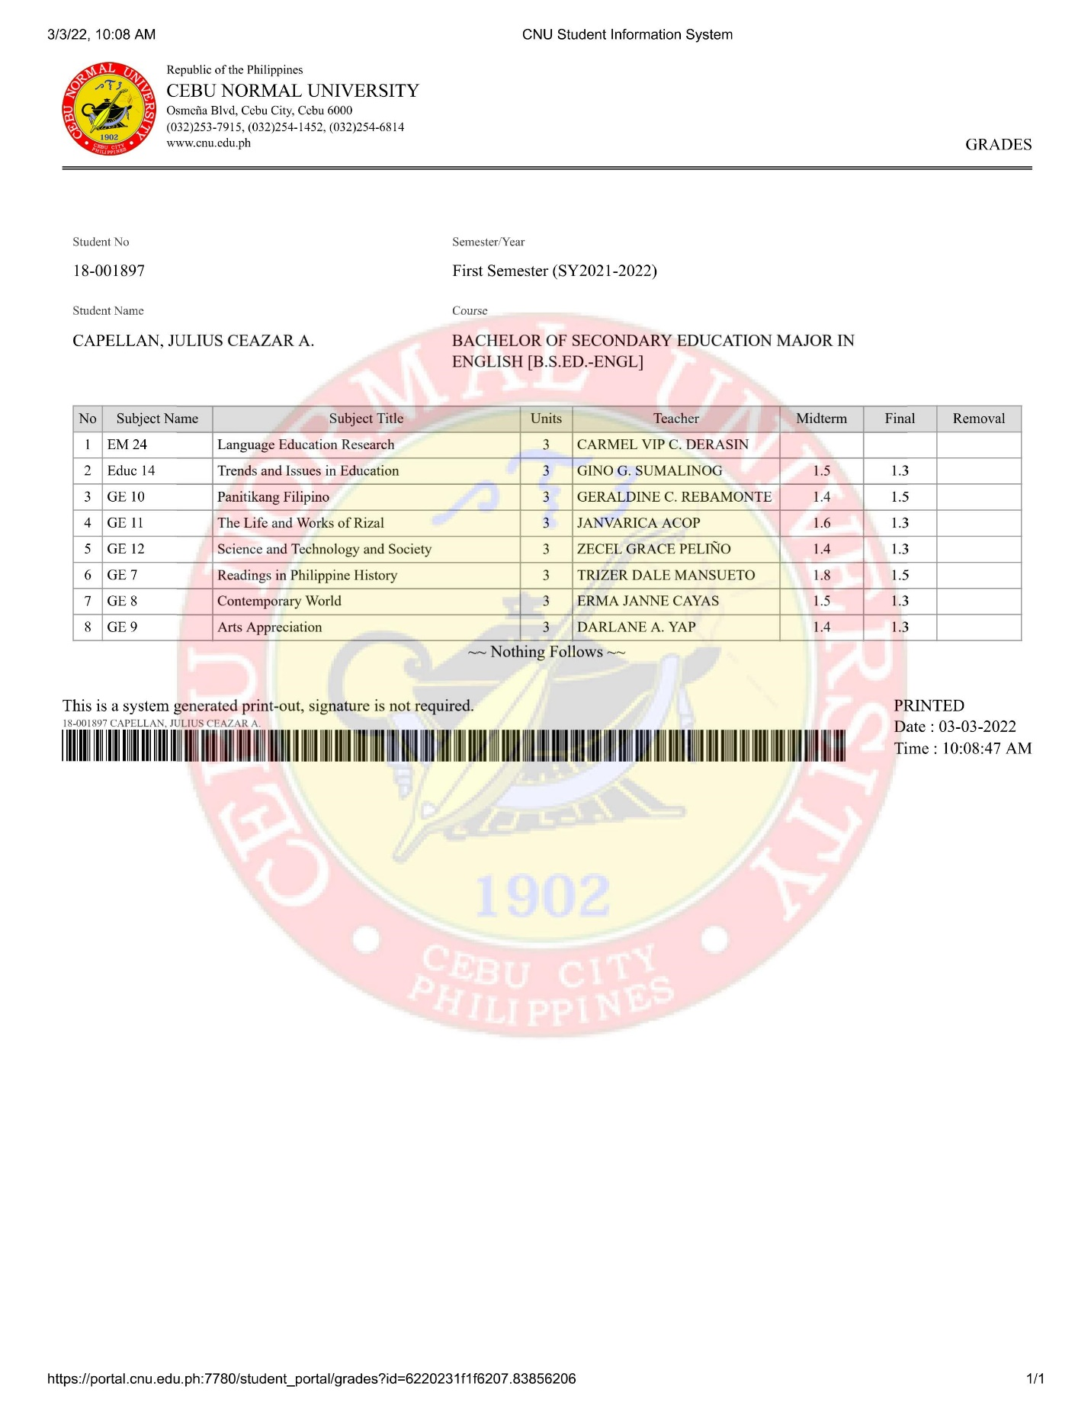
4TH YEAR- 2nd Sem
