Sketch of Residence
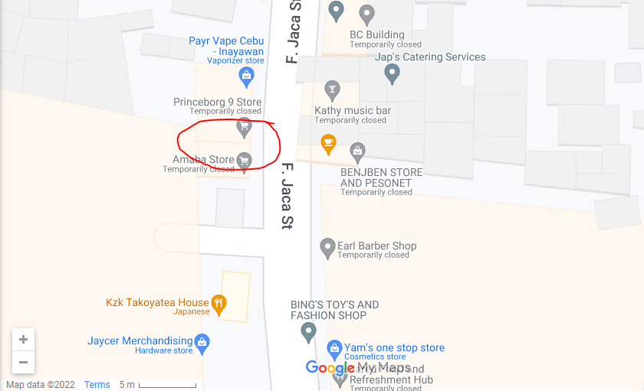
Canencia, Bench Yasmin
*In between these 2 stores are our entrance area.
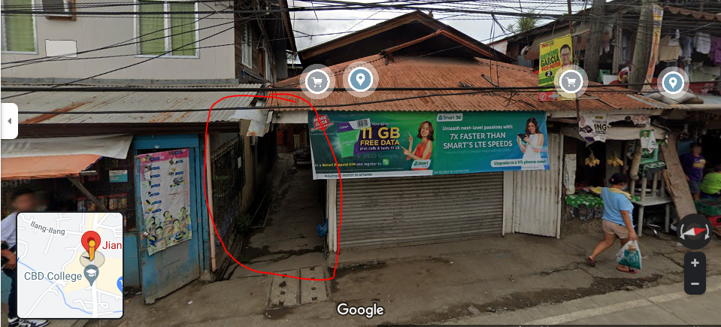
*Picture of entrance area

