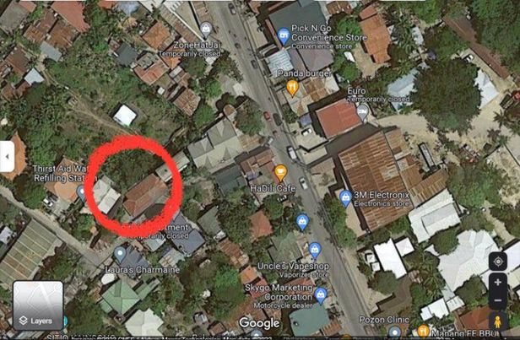
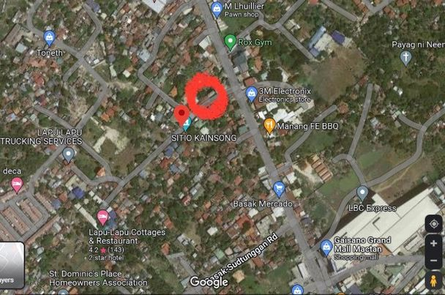
LANDMARK: HOTEL EUROPA, AND LAPU-LAPU COTTAGES.

