LETTER OF RESIGNATION
Ruth C. Garzo
080 J de Veyra St. Carreta, Cebu City 6000 | 09981995627 | ruthgarzo1226@gmail.com

October 15,2024

Iploy OPC
Ayala Center Cebu Tower
Bohol Street, Cebu Business Park Cebu City 6000

Dear Mr. Lord Holmes Arocha,

I am writing this letter as a formal notice of resignation from my role as a CSR- Initial Authorization Specialist at iPloy, effective today October 15, 2024.

I sincerely apologize for the abrupt timing of this announcement, however I have made this decision due to personal reasons that would require my full attention at this time. I have to take care of my daughter since she will be starting her preschool years and no one is able to help me with her. I need to prioritize my personal life at this juncture.

Thank you for all your help and support and I wish you, the company and my colleagues all the best for the future.

Best Wishes.

Sincerely,

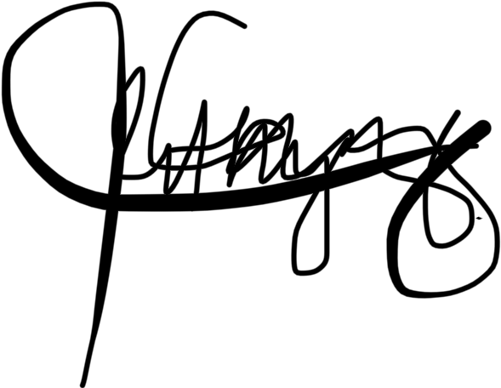

Ruth C. Garzo

