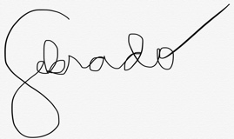
Dina A. Ebrado
Fuentes Rd. Pajac, Lapu Lapu City
09275356865
dingiranera69@gmail.com
May 7, 2023
To whom it may concern,
Please accept this letter as my formal resignation from my position as a customer service representative at iPloy, effective tomorrow. I apologize for not being able to give more notice. However, I regret that, due to circumstances beyond my control, I need to resign right away. Personal reasons necessitate that I vacate my position and focus on improving myself.
This was not an easy decision to make. I’ve enjoyed working at iPloy. I highly appreciate the opportunities for growth and development you have provided during my tenure. Thank you for your guidance and support.
Many thanks for your understanding.
Sincerely,
Dina Ebrado

