




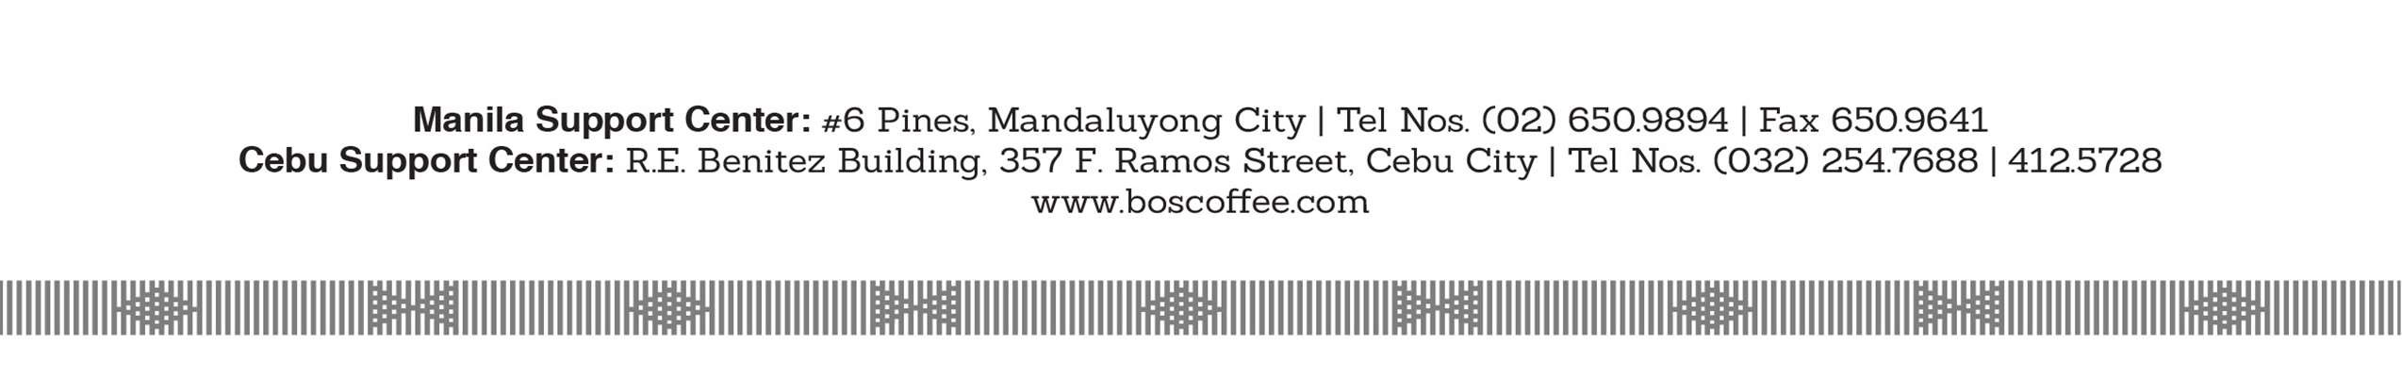

C E R T I F I C A T I O N

This is to certify that
Mr. Jan Lyndon V. Orais
is an employee of
WS and Landin, Inc.
from June 13, 2019 up
to present and currently holds the position of Store Supervisor.
This certification is upon the request of the above employee

.
Issued this 16th day of May 2023, Mandaluyong City.

RICHEL D. BORDE
Senior Manager
Human Resource Department

