“SKETCH OF RESIDENCE”
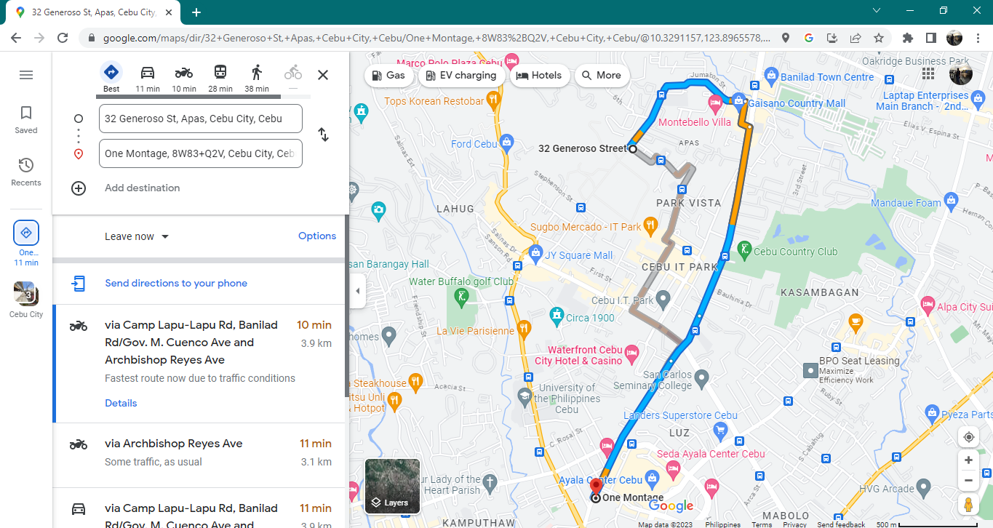
Present Address : 32 Generoso St., Apas, Cebu City

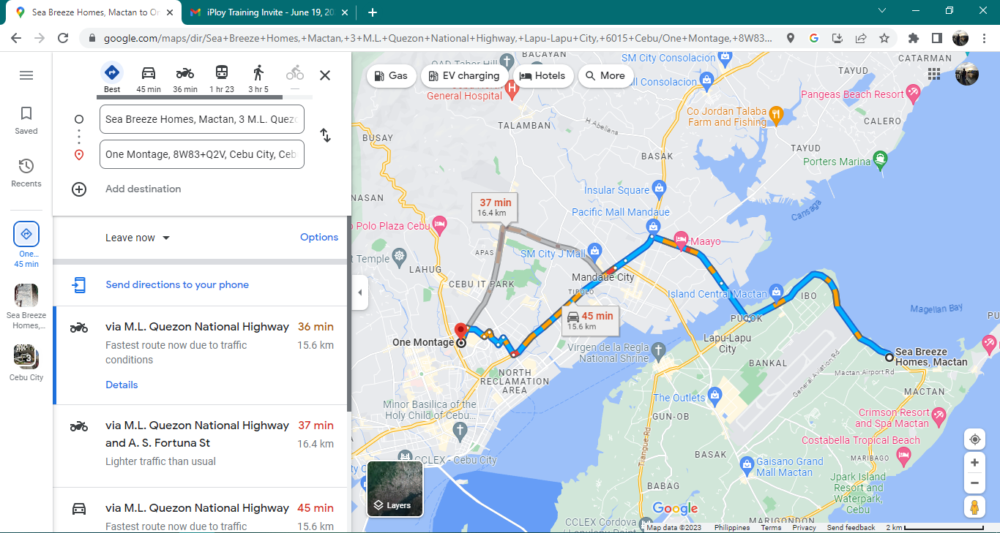
Contact person’s Address: (Miriam Llorin Cabahug) Sea Breeze Homes, Mactan, Lapu-lapu City

