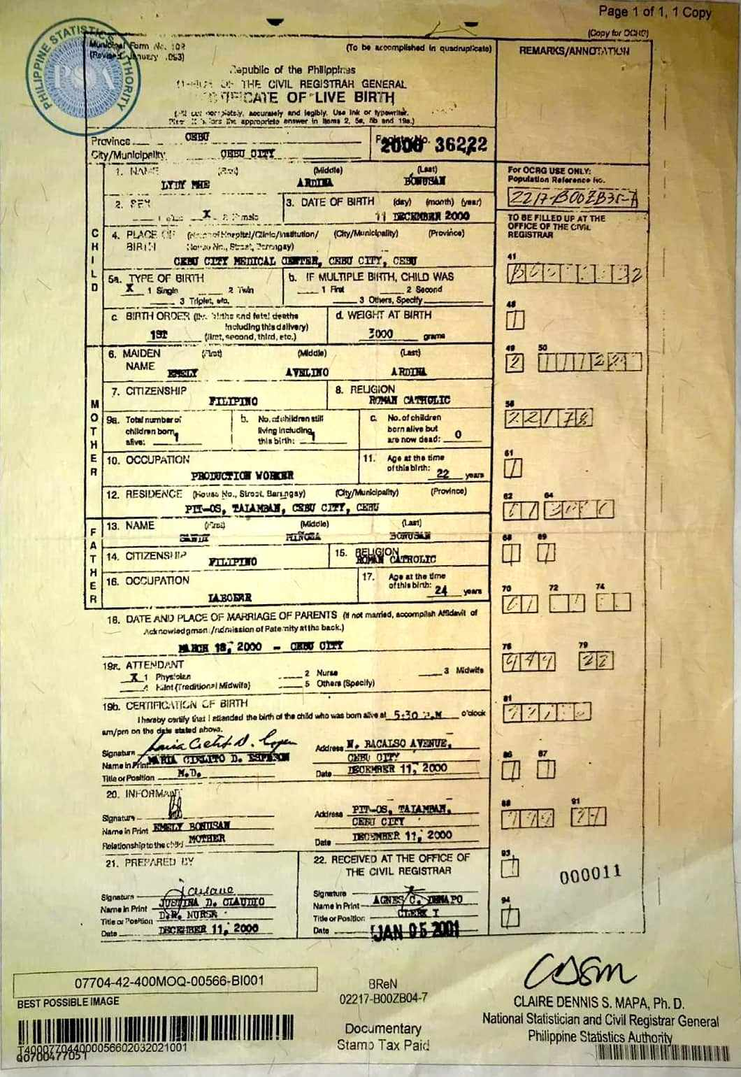
PSA
NBI - NATIONAL BUREAU OF INVESTIGATION

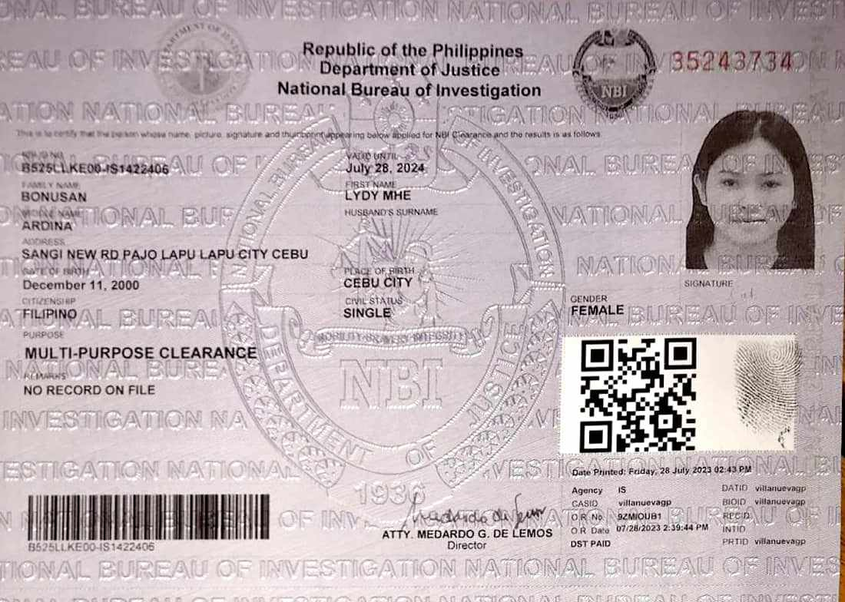
SKETCH
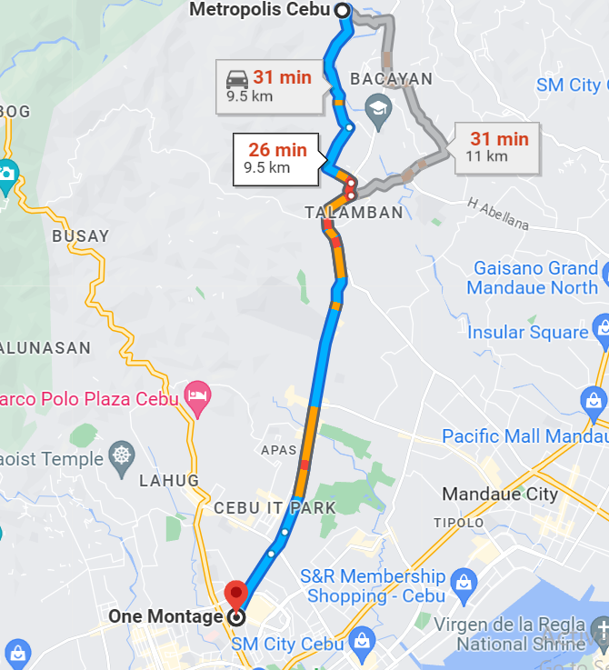
TRANSCRIPT OF RECORDS - PAGE 1

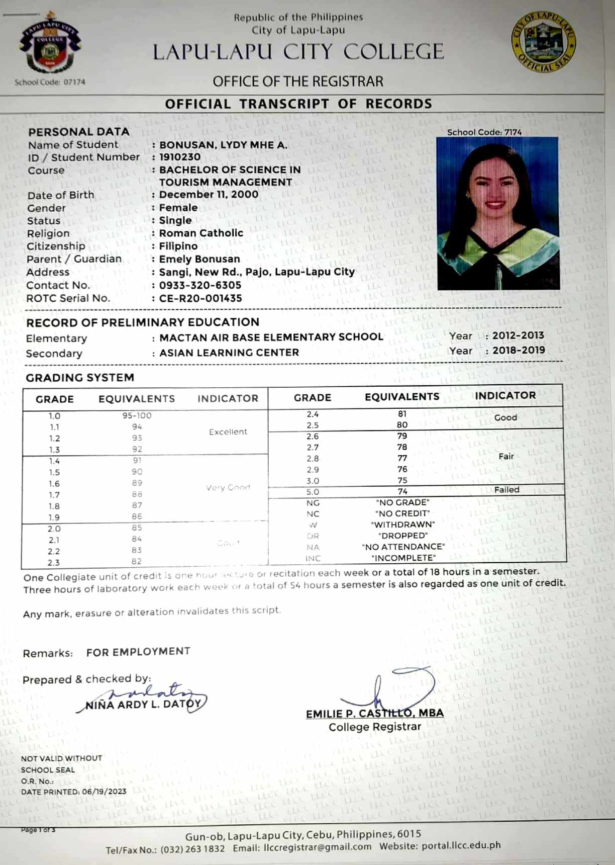
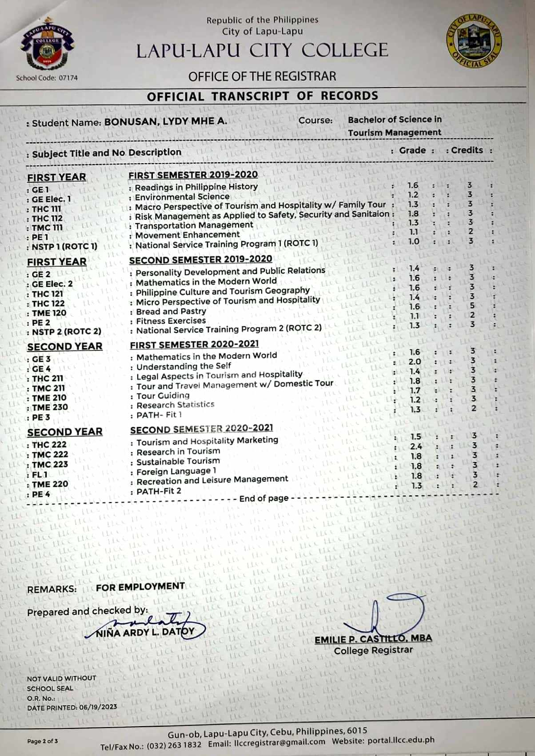
TRANSCRIPT OF RECORDS - PAGE 2

TRANSCRIPT OF RECORDS - PAGE 3
