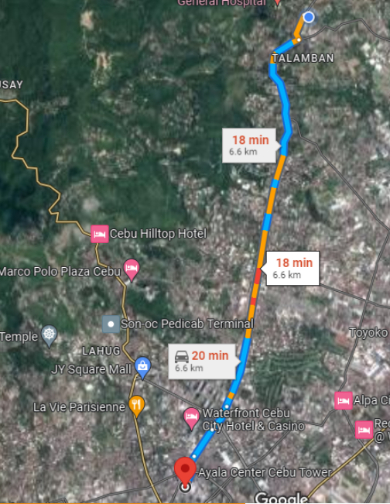
https://gyazo.com/87279c2878828a95fd5133719638385a

