Quintana, Lyla Chairein T.
Employee ID: 4121

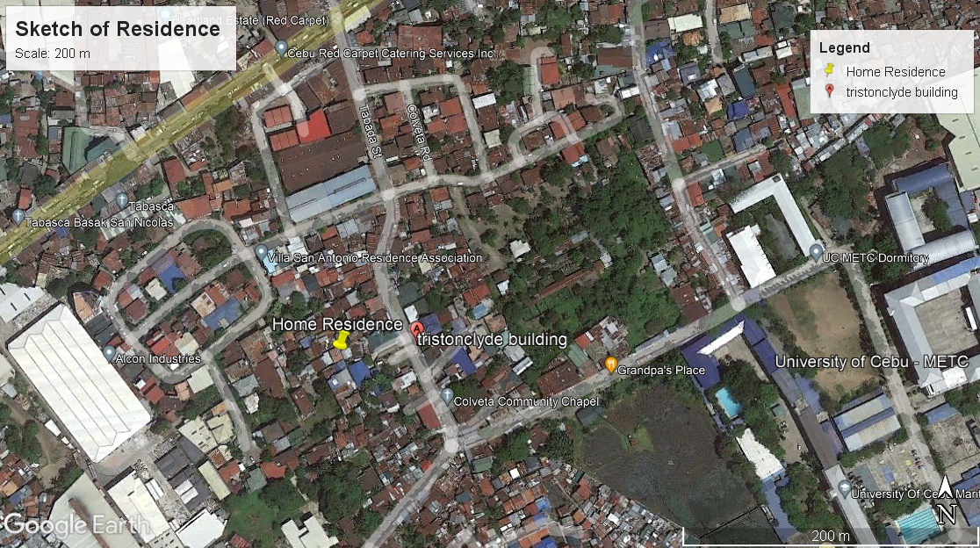

The map shows the landmarks and roads near my home address. The yellow pinned place is the location of the house.

