E-ASIA TECH SOLUTIONS

4/F DG3 Building, Escario St., Capitol Site,
Cebu City, Philippines 6000

Employee Clearance Form
Form to be attached to personal record

Name of Employee: | Denise Jean G. Matutinao | Account / Project: | Fromyouflowers
Employee ID | 1608 | Employment Date: | September 2018
Supervisor | Junwel Rivera | Position Type: | Customer Service Representative
Job Title | Customer Service Representative

Type of Separation
Resignation | ☐ Termination | ☐ Lay Off | ☐ Retirement
☐ Seasonal Lay Off | ☐ Leave of Absence | ☐ Probationary | ☐ Department Transfer
☐ Institutional Transfer | ☐ Other __________________

Contact Information
Mailing address: | dendirts@gmail.com | Address: | Guadalupe Cebu City
Separation Date: | May 2021 | Contact: | 09567888345

Employee Responsibilities
- I understand that my E Asia Tech Solutions email address will be deactivated the day after my last official work day and I have notified appropriate email contacts of this change.
- I have cleared all matters pertaining to petty cash funds and state expenditures. I understand that if I owe any outstanding monetary obligations it may be withheld from my final paycheck.
Final Time Card Approved? | Yes
Employee Resignation Letter Received? | Yes
Notifying the following department(s) to delete the relevant information as per rules & regulations.
IT Department: Francis Niño Li/ Abdul Amama/Ronniel Lomocso |  | HR Department: Carl Daryl Alex M. Sita

____________________________ Date: ___July 29 2021_________
Employee name: Denise Jean G. Matutinao


CARL DARYL ALEX M. SITA
HR Generalist
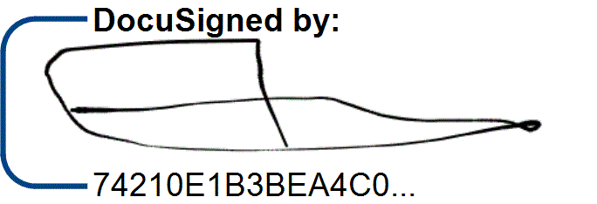
LEMUEL D. MANISAN
Managing Director

