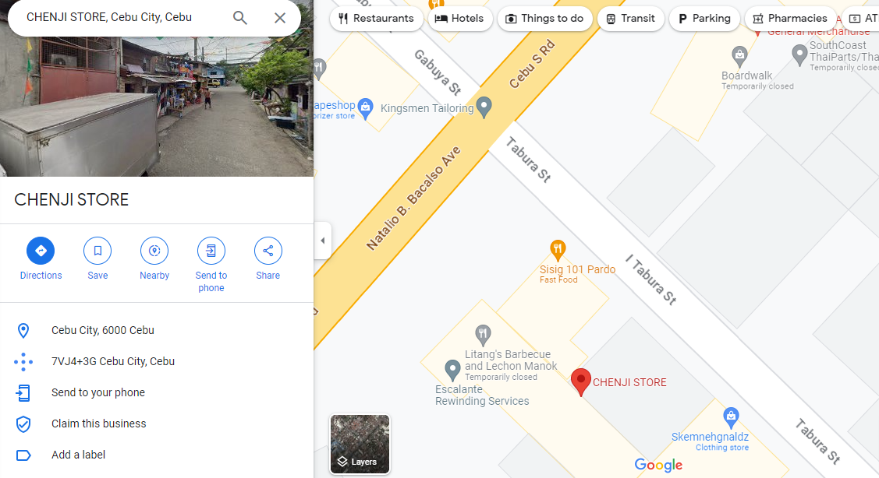
Name: Chelline Dinapo
Present Address: 33 I Tabura Street Pardo, Cebu City (Landmark: Chenji Store – In front of Kingsmen Tailoring)

