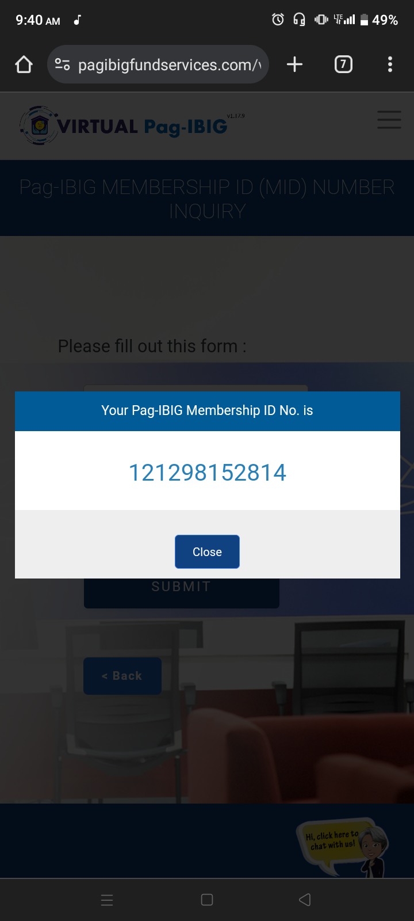
Name: Ruby Grace A. Nacario
Pag-ibig membership ID no.
Note: Hello Ma'am/Sir, The Pag ibig also sends a memo regarding my pag ibig status at onboarding@iploy.com

