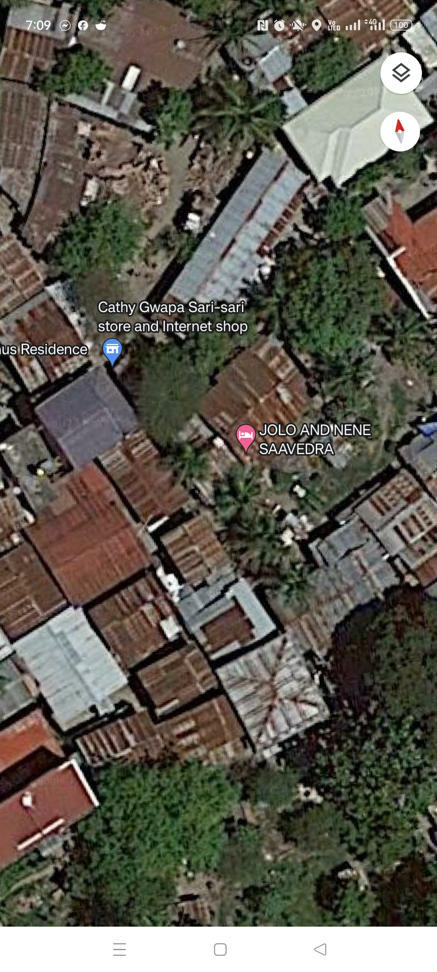
SKETCH OF RESIDENCE - NIA KIMBERLY ESTOCONING -4372

