10/14/24

IPLOY
16th floor, One Montage, Archbishop Reyes Ave, Cebu City, Cebu
6000.

Dear Rhay/Management

Please accept this letter as my formal resignation from Customer Service Representative effective immediately.

I sincerely apologize for what I did to the company’s asset. I’d love to stay and be employed with the company. I’d love to have my salary deducted every payday if I’m given the chance to come back but with What I did I’m pretty sure I will not be accepted since that was the advice I was given.

Thank you for the great opportunities to pursue my interest in numerous areas, which have prepared me well for my next challenge.

Please let me know how I can be of assistance during the transition period. I wish you and the company the very best going forward.

Sincerely,

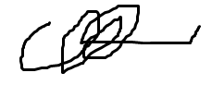
Renan S. Mandajuyan
Employee ID: 4478

