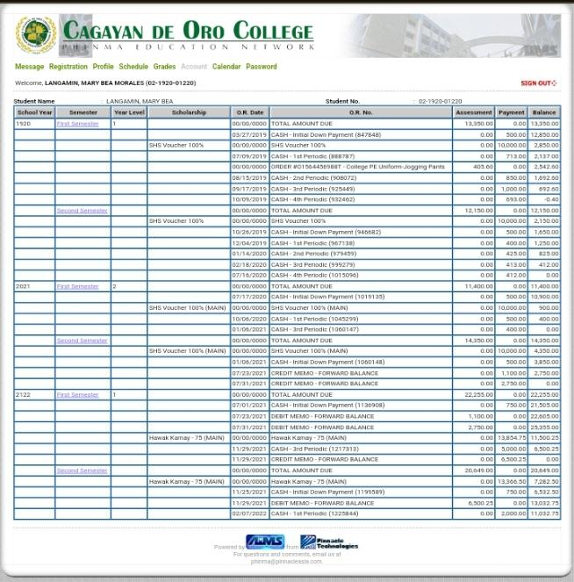
STATEMENTS OF ACCOUNT (SOA) IN MY PREVIOUS SCHOOL-PHINMA COC
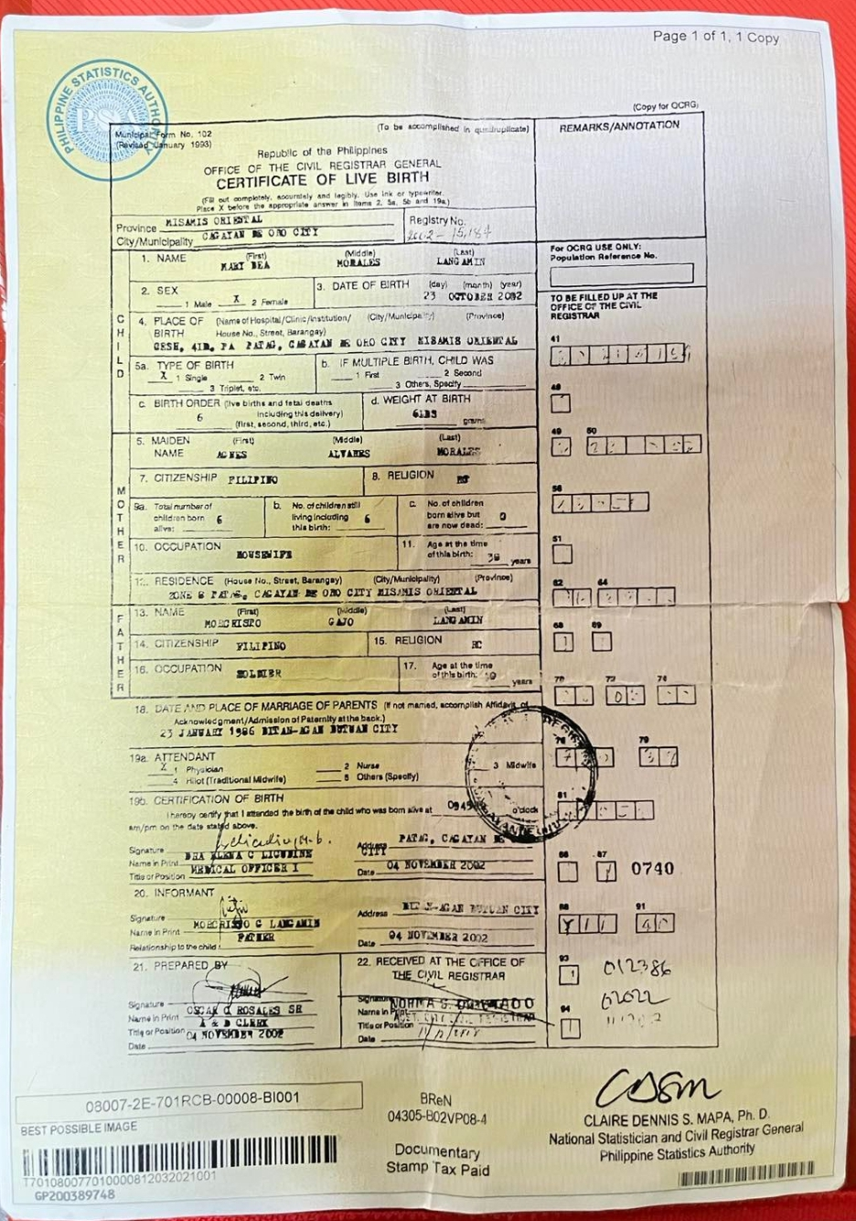
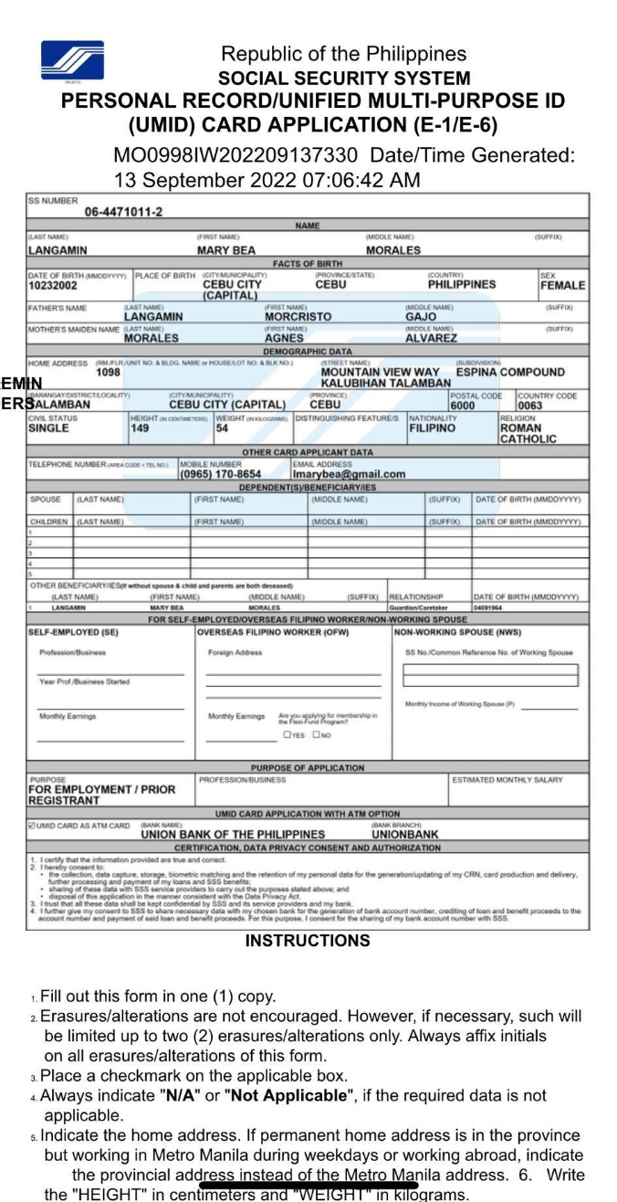
E1 FORM FROM SSSS
TEMPORARY EXIT FORM FROM MY OREVIOUS COMPANY-COE TO BE FOLLOWED ALONG TIH THE 2316.
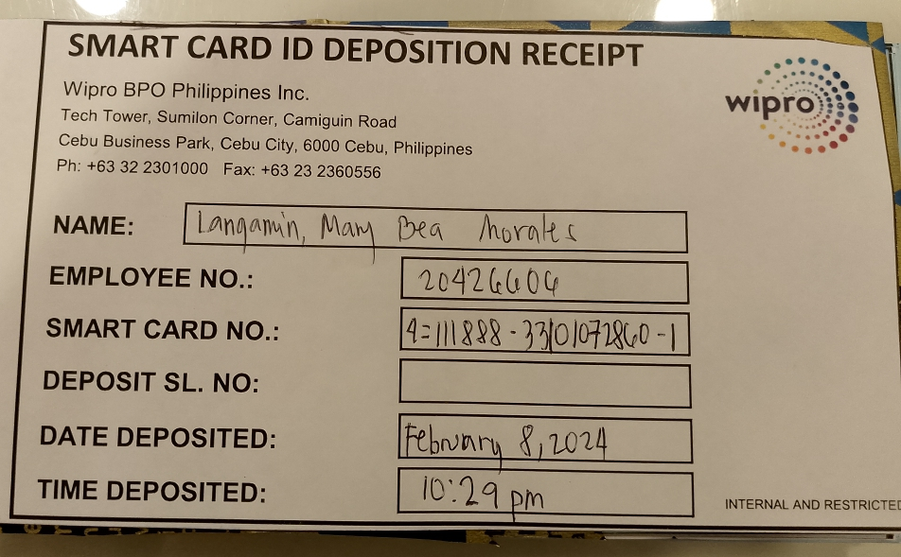
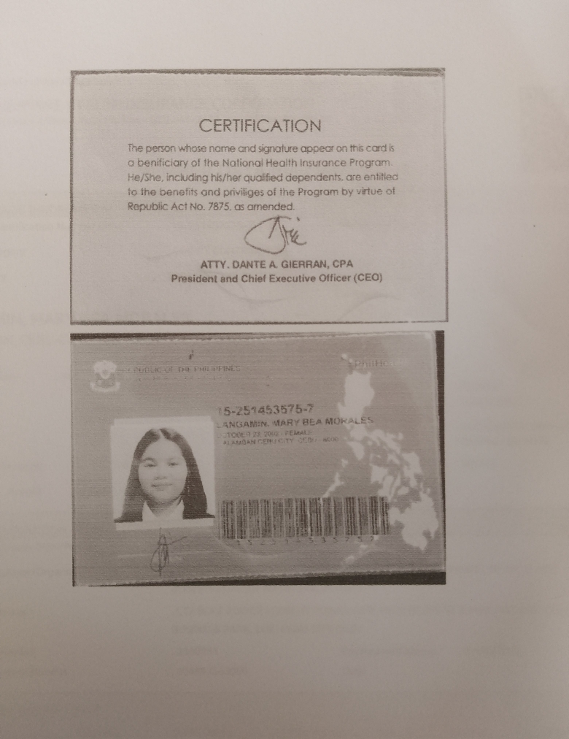
PHILHEALTH ID CARD PHOTOCOPIED
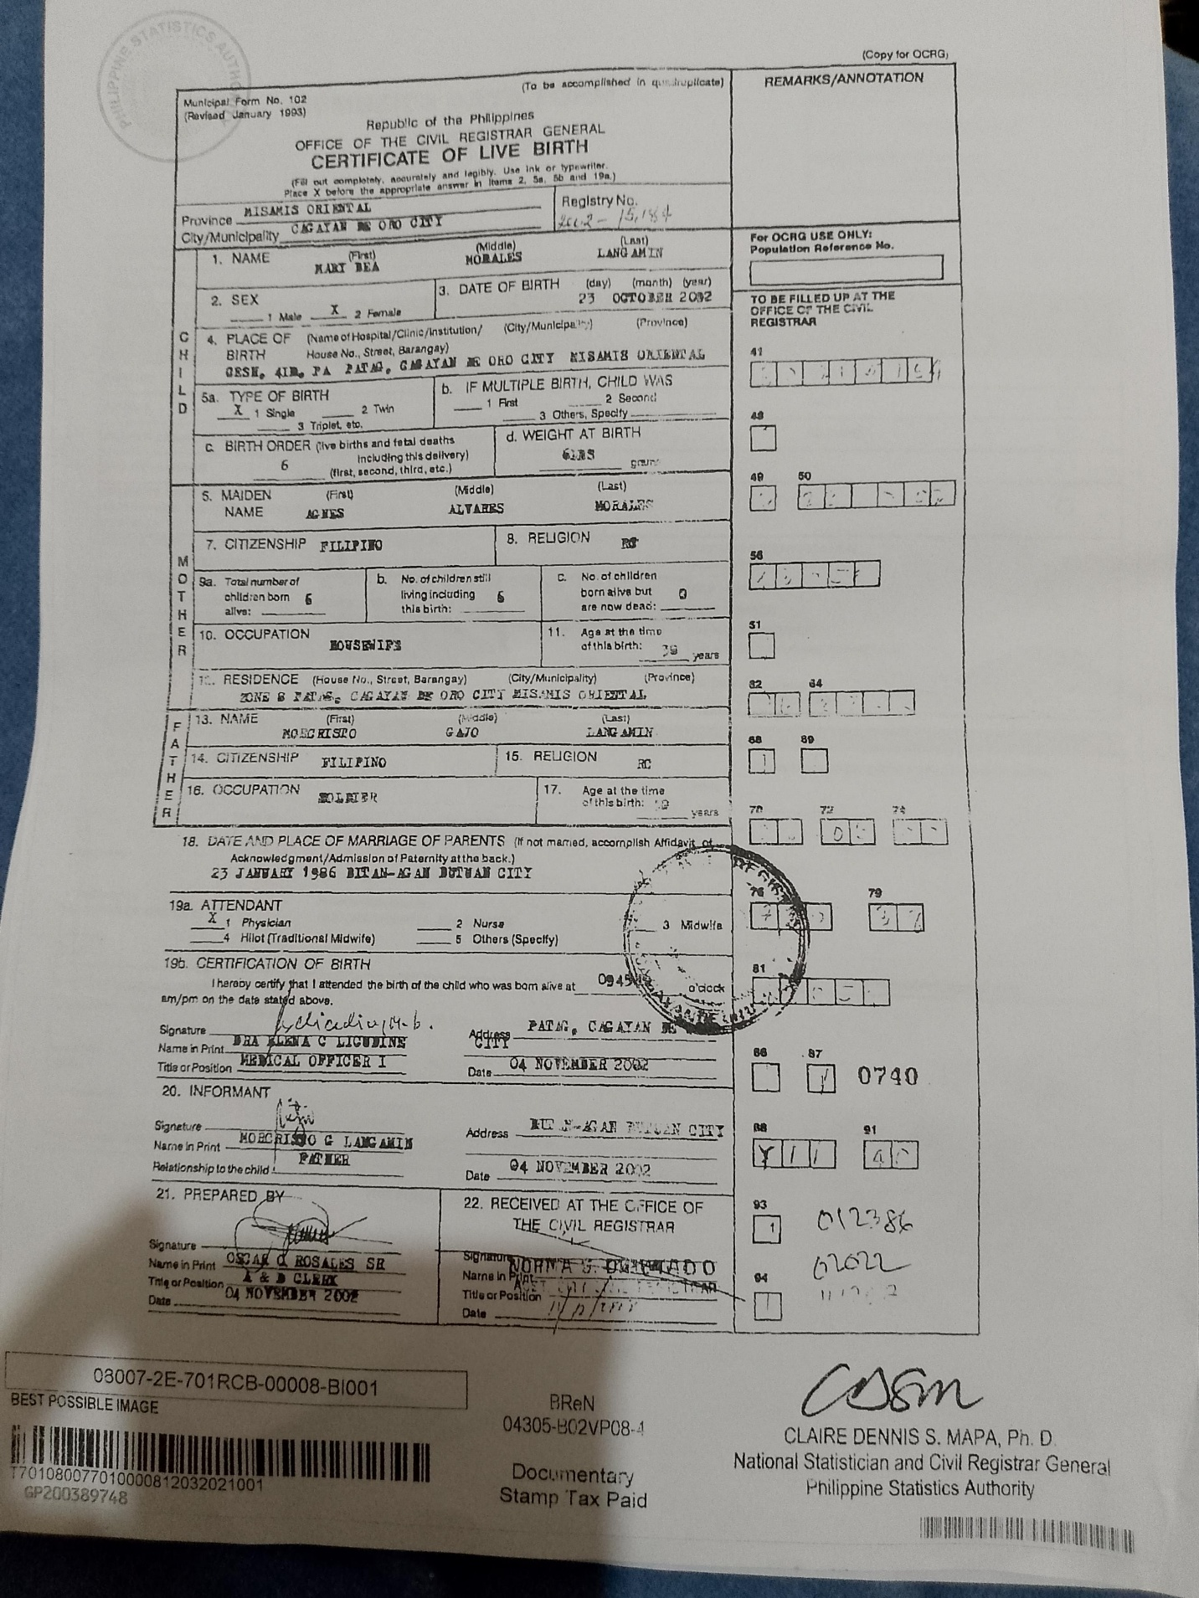
PSA
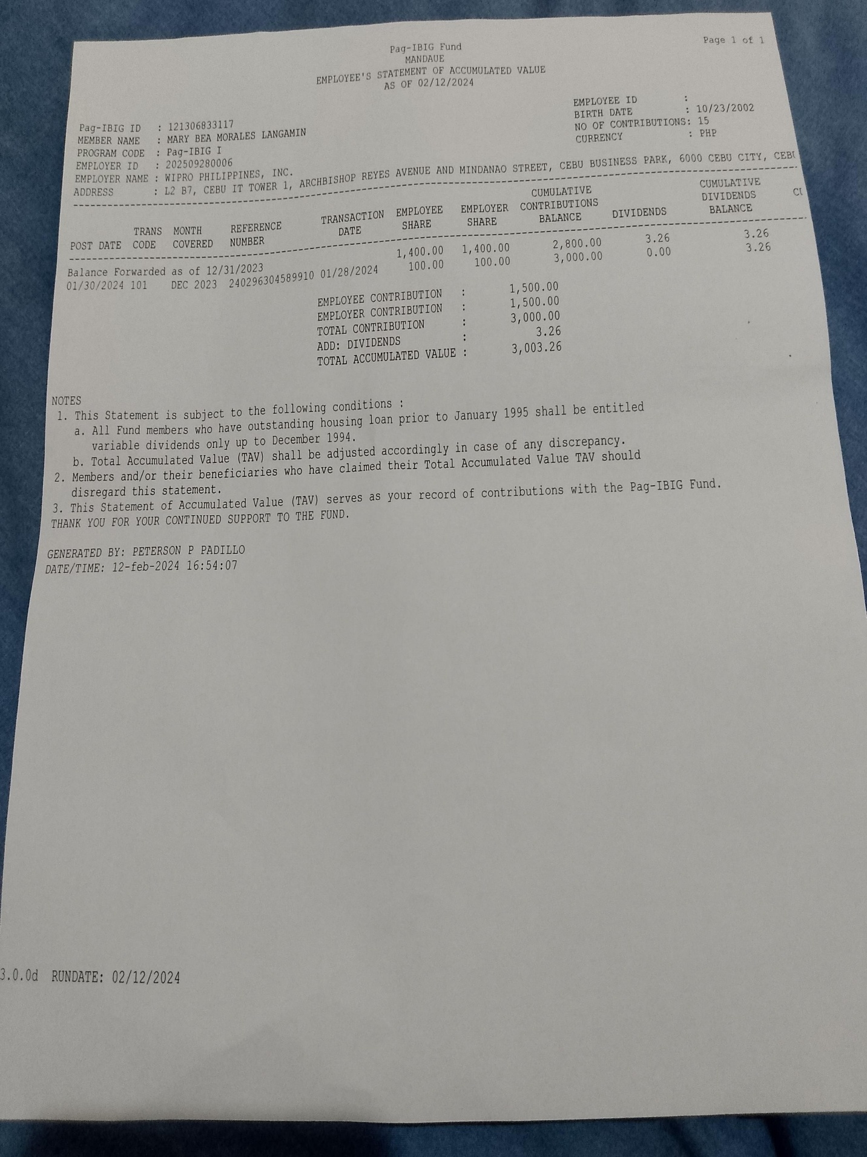
PAG IBIG
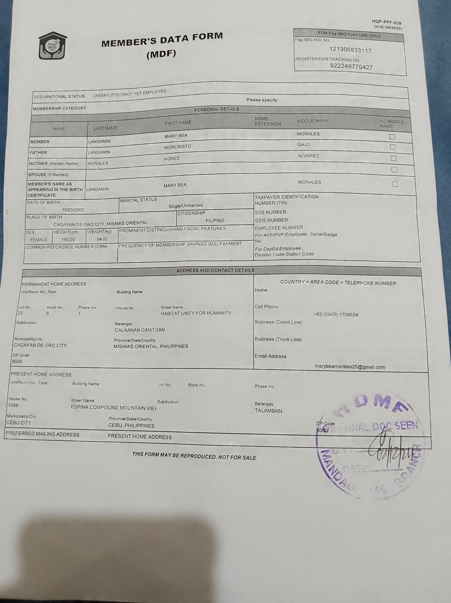

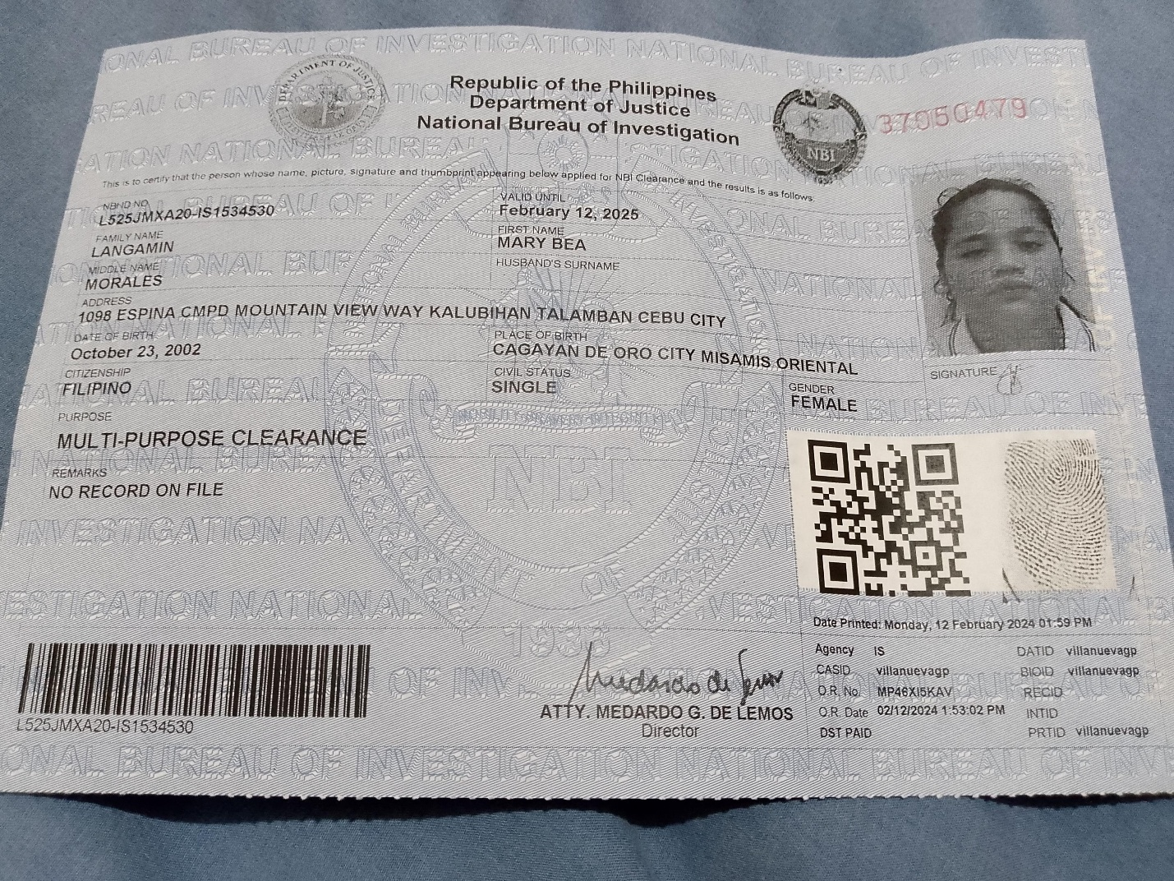
NBI CLEARANCE
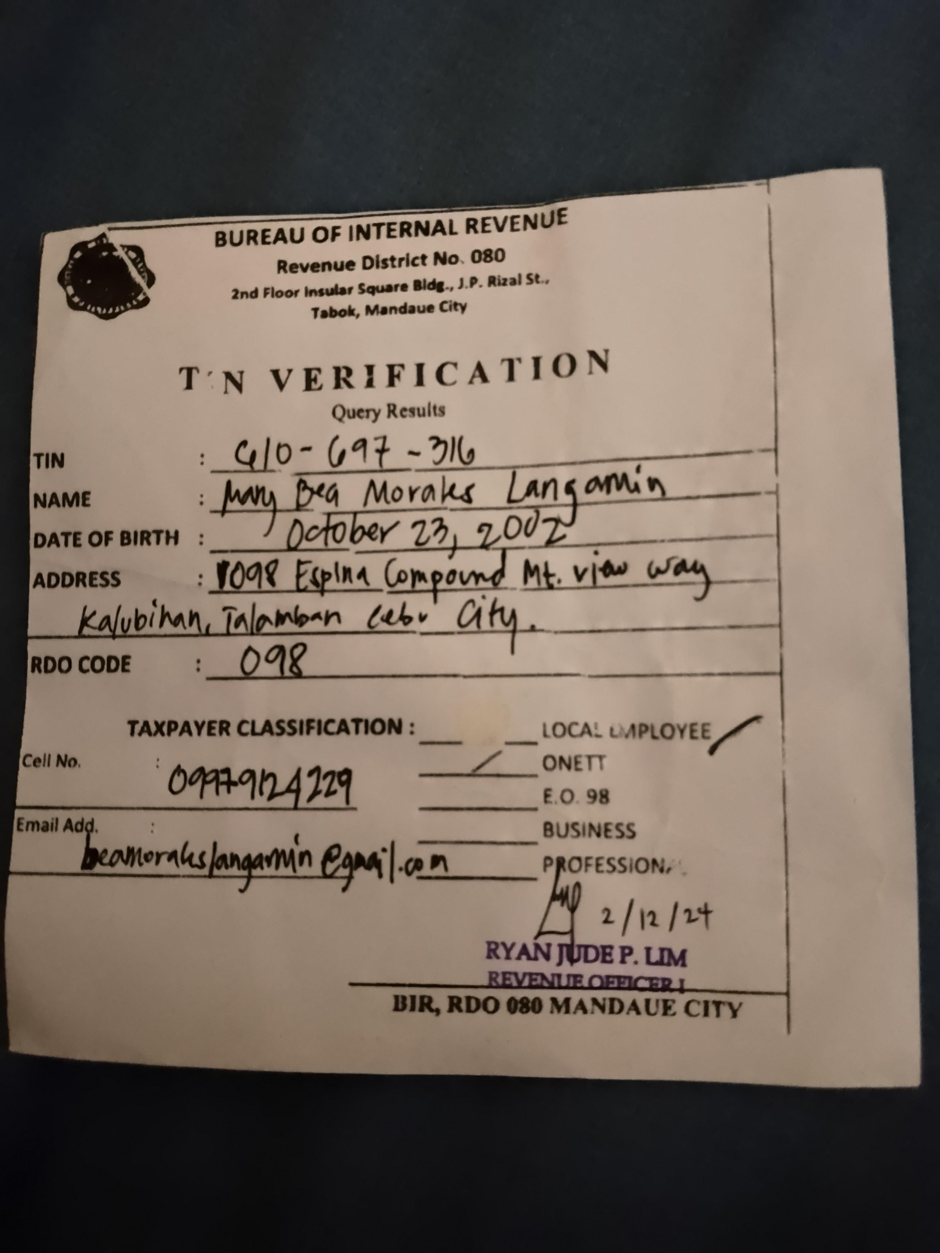
TIN VERIFICATION: 2316 WILL BE TO BE FOLLOWED.
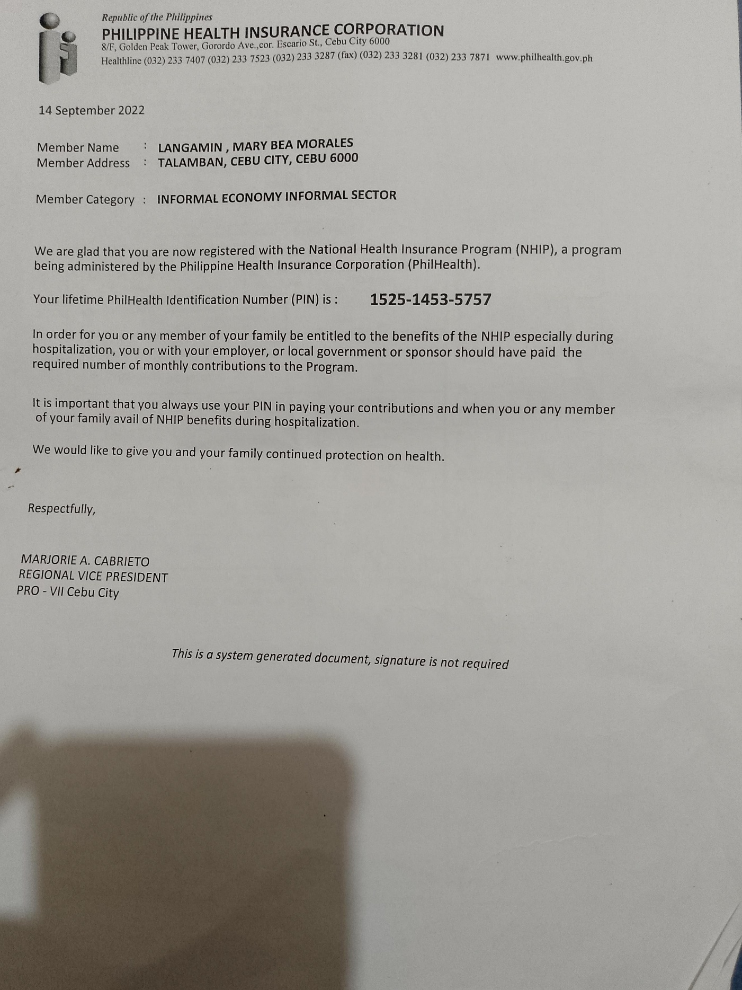
PHILHEALTH
