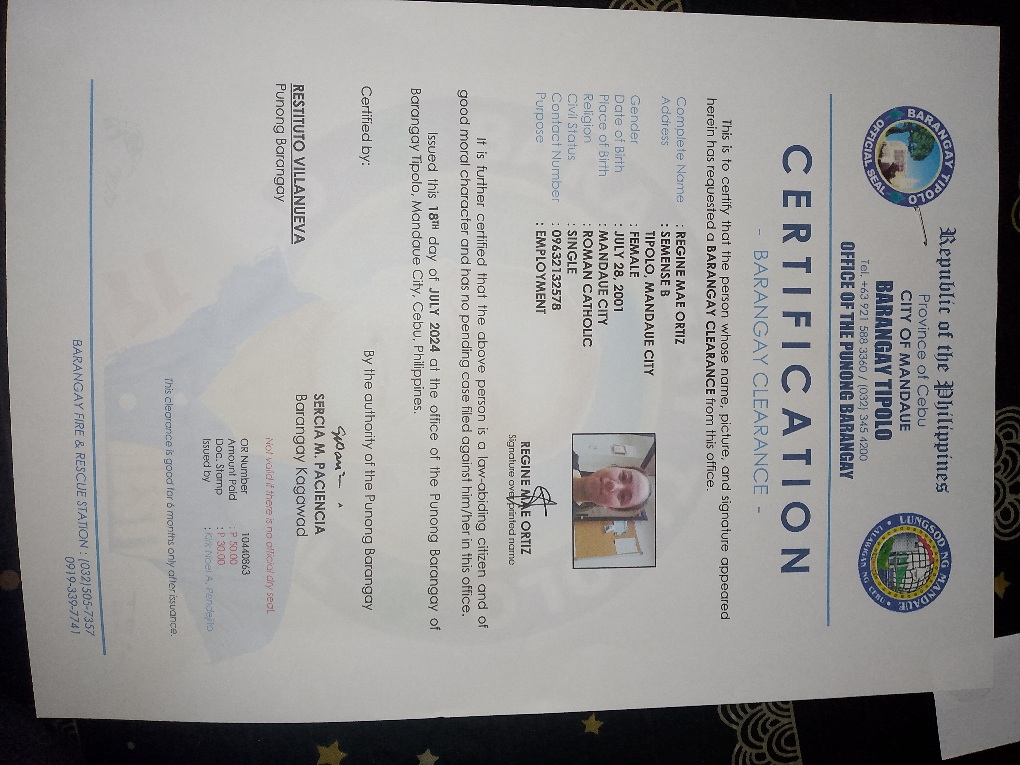
BARANGGAY CERTIFICATE

