October 15, 2024

Mary Vito
Team Leader
IPLOY Staffing Solutions
9th Floor, Ayala Center Cebu Tower
Bohol Street, Cebu Business Park
Cebu City 6000

Dear TL Mary,

Please accept this letter as a formal resignation from my post as a Customer Service Representative effective today. I am leaving for health and family reasons. I can’t balance family life and work in addition to my blood pressure going up.

I enjoyed working with you and the team. I am thankful for the support that you have given me since Day 1. And I am very sorry for the abrupt decision. I wish you all well and thank you for your consideration.

Sincerely,

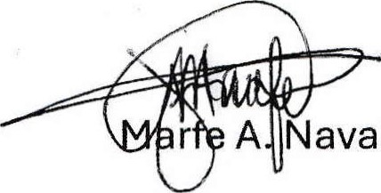

Marfe A. Navallo llo

