December 5, 2022
iPloy OPC
16th floor, One Montage
Archbishop Reyes Ave.,
Cebu City, Cebu 6000

To whom it may concern:

Good day!

Please accept this letter as notice of my resignation from my position as a Confirmation Specialist. My resignation will take effect today December 5, 2022.

As you know I had my first child last August 21, 2022 and have decided that I will not be returning to work after my maternity leave since no else will look after my child.

I would like to thank you for the professional and personal development that the company has provided me. I appreciate the opportunity to have worked in this company and the trust and training the company has given me throughout my stay.

I had been fortunate enough to have been part of the iPloy OPC and I wish you every success in the future.

Thank you.

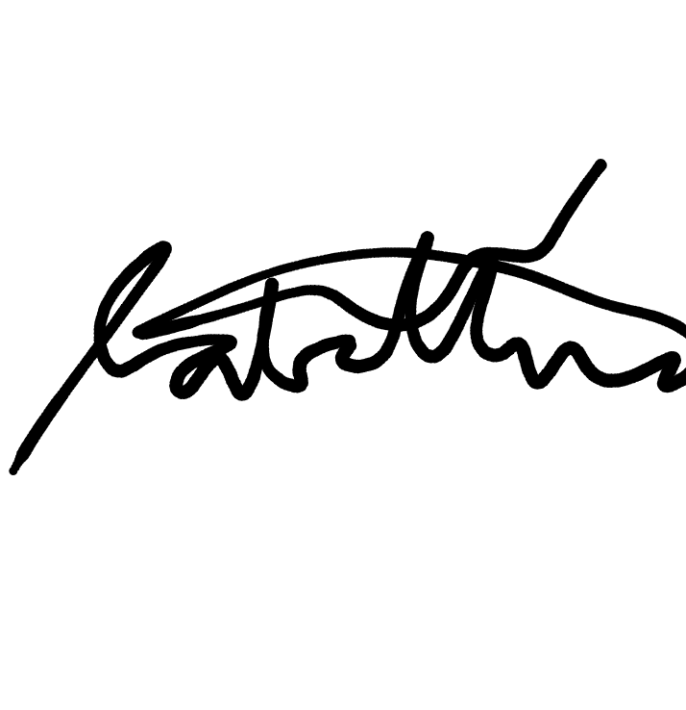
Sincerely yours,
April Jane Sabellina

