iGROW COACHING FORM

Full Name: Gypsy Angel Ferraren | Date: July 19, 2021
Employee No.: 1564 | Immediate Supervisor: Lady Mae Lao

Issue / Goal - What is the issue and goal of the coaching session?

Agent wasn’t able to reach the monthly quota for the month of June
TOTAL | QUOTA |  | AVE
743
865
1608 | 1650 | 97%

Reality / Options – Root Cause Analysis and Agent’s Feedback

Our warehouse doesn’t have enough orders.

Way Forward – Action Plan and Setting Proper Expectations

Ask and inform my team lead ahead of time to let her know and so she could send me orders to work to.

Set proper expectations that next time that the agent commits the same offense stated above. This will be dealt accordingly.

Employee Signature: | Date: July 19 2021
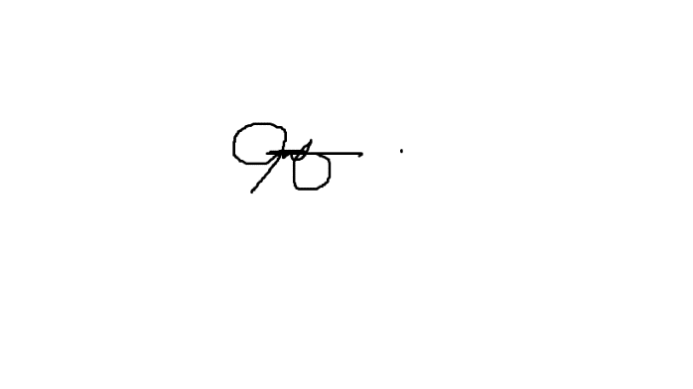  Supervisor Signature: 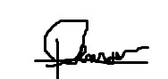 | Date: July 19, 2021

