C E R T I F I C A T I O N

This is to certify that MARY ROSE AIRENE VILLAGONZALO was a Regular employee of Qualfon Philippines, Inc. She occupied the Customer Service Representative position under the Operations Department and had worked in the company from April 5, 2016 to February 15, 2020. She has been cleared from all accountabilities and liabilities.
This certification is being issued upon the request of MS. VILLAGONZALO for whatever legal purpose it may serve.

Done in Cebu City, Philippines this 12th day of August 2020.

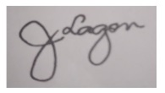
Janette B. Lagon
Records and Information Staff
PERSON OFFICE

