April 18, 2023

**IPLOY OPC-CEBU**

16th Floor, One Montage,

Archbishop Reyes, Cebu City

To Whom It May Concern,

Dear Sir/Madam,

I regretfully submitted my resignation from my position as a Customer Representative effective April 17, 2023, and my sincere apologies for being unable to provide two weeks notice. Although I love my job, but I regret that due to personal matters, I must resign immediately.

My reasons for leaving are deeply personal, but rest assured this is not related to dissatisfaction with my job, the company, or co-workers. Thank you so much for the support that you have given me during my time at the company. I place incredible value on the years of guidance you've provided and i wish you well in the future.

Sincerely,

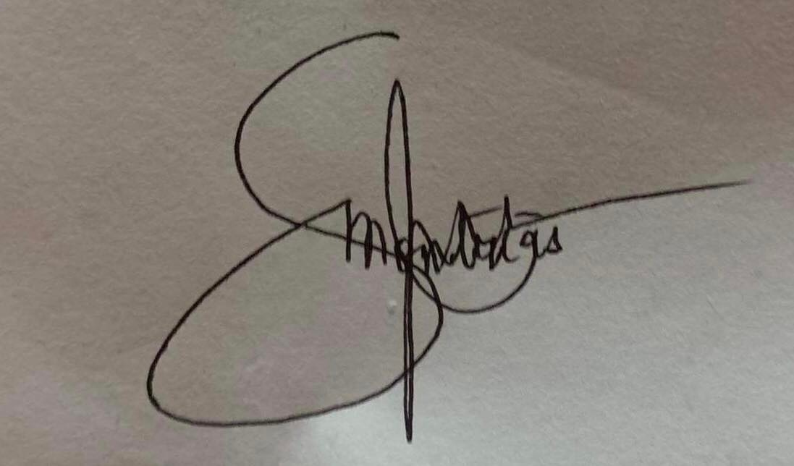

JESSON C. MONTRIAS