Ms. Marishka Iris Arcilla and Ms, Ramelyn Castanares

HR Managers

iPloy, OPC

9th Tower, ACCT, Cebu Business Park

Dear Miss Maw and Miss Rams,

Upon careful consideration, I regret to inform you that I am resigning from my position as a Training Coordinator. For the reason that I can no longer sustain the graveyard shift schedule, which greatly impacts my momentum, my mental and physical health as of the moment.

As you all know, recently, I just lost a family member, someone who was really close to us. And with my late aunt’s passing, due to numerous health problems, it had a great impact on my family, especially on my parents. My mother personally shared her fair share of concerns as to why she prefers me to work on a day shift schedule and I would like to respect that.

My last day at work will be on April 7, 2023, I will be rendering 1 month to make sure that I can finish my pending tasks. Please know that I am thankful for the opportunity and growth that the company has given me. And with this said, I hope I have your support and understanding, I would really appreciate it.

Best wishes to the company and its future growth!

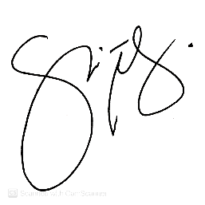

Kind Regards,

Jennica “Nica” Ninalga

2470 – Training Coordinator