**CERTIFICATION OF EMPLOYMENT**

To whom this may concern:

This is to certify that **EMMANUEL MICHAEL V. OSIA** as **OUTBOUND SALES EXECUTIVE** from **August 17, 2021** up to **October 7, 2021.** *FORWARD THINKING SERVICES PHILIPPINES, INC (FTSP INC),* a Business Process Outsourcing (BPO) company with office address at 15th floor, HM Tower, corner West Geonzon St., Cebu IT Park., Apas, Cebu City.

This certification is issued to **EMMANUEL MICHAEL V. OSIA** upon his request for whatever legal purpose it may serve.

Issued this 15TH day of December 2021 at Cebu City, Philippines.

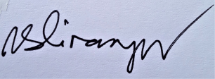

Vitus S. Dinampo

HRD Manager