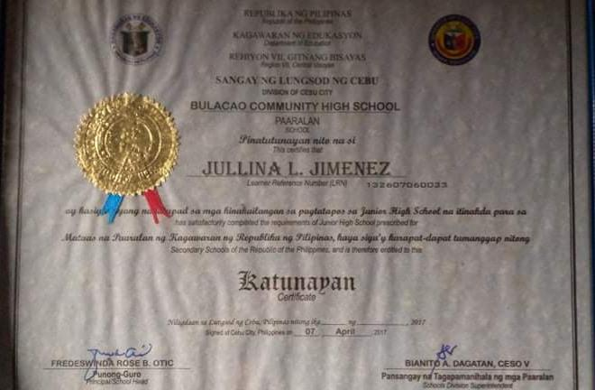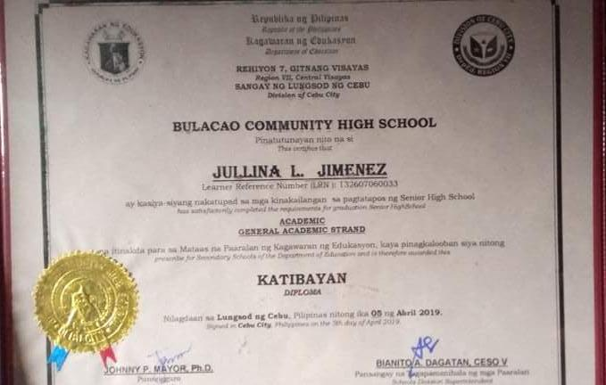JULLINA JIMENEZ

DIPLOMA (JUNIOR-SENIOR HIGH SCHOOL)