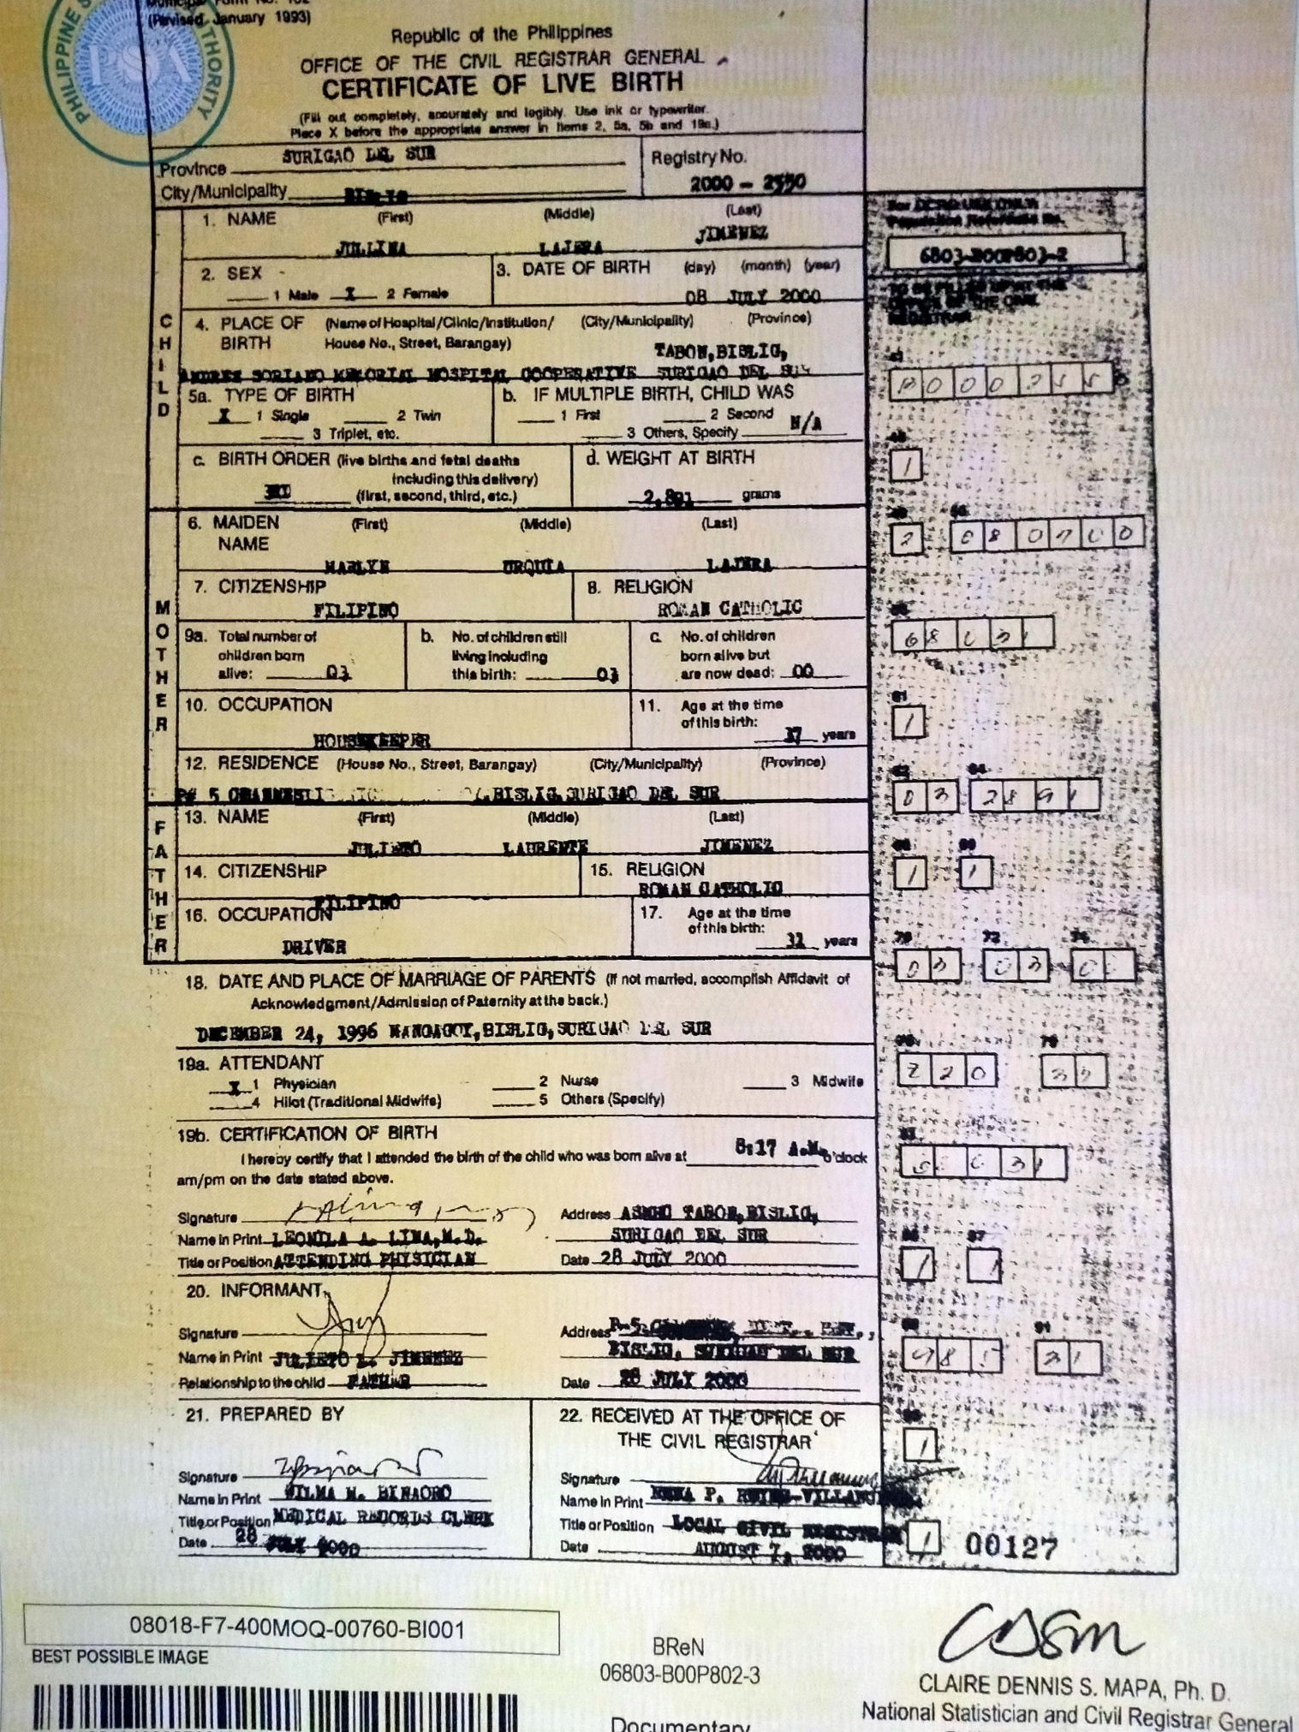JULLINA JIMENEZ

PSA (BIRTH CERTIFICATE)