C E R T I F I C A T I O N

This is to certify that Suzaine Canoy was an employee of vCUSTOMER
PHILIPPINES (CEBU) INC. (a Tech Mahindra Company) from 10/02/20 to 03/14/22. She held the position of Associate - Customer Support.

This certification is issued upon the request of Suzaine Canoy for employment purposes. vCustomer Cebu shall not be held liable if this certification is used other than the purpose indicated.

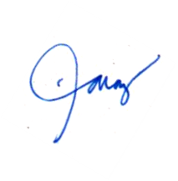
Issued this 12th day of May 2022, Cebu City, Philippines.

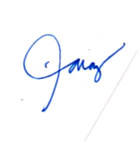
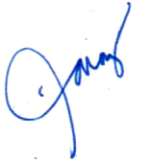
Noel Paraz
Associate Manager, Human Resources Cebu.
NP00467015@TechMahindra.com
For Employee Verification, please send an email to EmployeeVerificationRequest@TechMahindra.com

