

**Tech Mahindra Limited**

7th Floor Ebloc 3 Cebu IT Park, 14th Floor FCC Bldg., Cebu IT Park, Cebu City 6000, Philippines

CBU: Tel +63 32 410 6499

CERTIFICATE OF EMPLOYMENT

This is to certify that **Lories Ann Quindala** has been an employee of **VCUSTOMER CEBU, INC. (a Tech Mahindra Ltd. Company) from November 23, 2018** to **April 19, 2022.** He/she held the position of **Associate- Customer Support.**

This certification is being issued upon the request of **Lories Ann Quindala** for reference of employment with the Company. **VCUSTOMER CEBU, INC** shall not be held liable if this certification is used other than the purpose indicated. For inquiries, you may email us [to CebuER@TechMahindra.com.](mailto:CebuER@TechMahindra.com)

Issued on **April 21, 2022**

# Issued by:

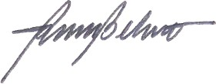**REYNALDO BELUSO II, JD.**

Manager, Human Resources